g]kfn ax';"rs ;j]{If0f @)&%÷&^
;'kl/j]Ifs lgb]{lzsf
Supervisor's Manual

s]Gb|Lo tYofÍ ljefu
yfkfynL, sf7df08f}

ljifo ;"rL
s|=;+= ljifo k[i7

- kl/ro 2

- ;'kl/j]Ifssf] sfd st{Jo 3
  - :ynut sfo{ If]qdf n}hfg' kg]{ ;fdu|L 4
  - oftfoft tyf a;f]af;sf] Joj:yf 5
  - :yflgo JolQm / clwsf/Lx?;Fu ;Dks{ 6
  - Sni6/df gS;f k|of]u 6
  - 5gf}6df k/]sf kl/jf/sf] vf]hL 7

- u0fgfsfo{ ;+rfng tyf ;'kl/j]If0f 8
  - u0fs tyf dfkgstf{sf] sfo{ lgwf{/0f 8
  - cg'Q/sf] Go"lgs/0f 9
  - afFsL /x]sf cGtjf{tf{ 11
  - dgf]an Pj+ sfo{k|]/0ff 12

- u0fssf] sfo{ d"NofÍg 13
  - cGtjf{tf{ cjnf]sg 13
  - sfo{ d"NofÍg 14
  - Sni6/ ;+rfng 14
  - kfl/jfl/s ;+/rgfsf] :ynut hfFr 14
  - ljefudf el/Psf k|ZgfjnL k7fpg] 16
cg';"rL A 6\ofAn]6n] sfd gu/]df s;/L sfo{ ;+rfng ug]{ 17

cg';"rL B ;'kl/j]Ifs CAPI PlKns]zg k|of]u 21
g]kfn ax';"rs ;j]{If0f @)&%÷&^

!= kl/ro

g]kfn ax';"rs ;j]{If0f @)&%÷&^ s]GbL|o tYofÍ ljefuaf6 ;+rflnt 3/kl/jf/ ;j]{If0f xf] . o;af6 ljif]ztM dlxnf tyf afnaflnsf ;DaGwL e/kbf]{ tyf ljZjfl;nf] tYofÍ cfk"lt{ x'g]5 . of] ax';"rs ;j]{If0f o'lg;]kmåf/f ljsf; ul/Psf] ;j]{If0f 9fFrfdf cfwfl/t 5 . of] 9fFrf cg';f/ g]kfn nufot ljZjsf w]/} b]zx?df ;j]{If0f ;+rfng x'Fb} cfO{/x]sf]5 / o; ;j]{If0faf6 k|fKt glthfx? cGt/f{li6«o:t/df t'ngf of]Uo x'G5 . ;+o'Qm /fi6« ;+3Lo afnsf]if -o"lg;]km_ sf] k|fljlws tyf cfly{s ;xsfo{df ;+rfng x'g] o; ;j]{If0f cGt/f{li6«o ;Gbe{df 5}7f}+ r/0fsf] xf] . o; ;j]{If0fsf] glthfaf6 afn d[To'b/, kf]if0f, afn :jf:Yo, vfg]kfgL tyf ;/;kmfO{, k|hgg\ :jf:Yo, k|f/lDes afNosfn ljsf;, lzIff tyf ;fIf/tf, afn cg'zf;g, Pr=cfO{=eL=tyf P8;\, cfd;~rf/df ;"rgfsf] kx'Fr / ;"rgf k|ljlwsf] k|of]u, ;'lt{hGo tyf dlb/f ;]jg;Fu ;DalGwt ;"rsx?, cflb tYofÍx? pknJw x'g]5 .

g]kfn ax';"rs ;j]{If0f, @)&%÷&^ -NEPAL MULTIPLE INDICATOR CLUSTER SURVEY, 2019, NMICS6) sf] gd'gf (Sample) 5gf}6df k/]sf Sni6/x? (Enumeration areas) sf] :ynut sfo{ (Field work) df ;+nUg x'g] sd{rf/Lx? ljleGg 6f]nLdf afFl8Psf 5g\ . k|To]s l6ddf tLg hgf dlxnfu0fs, Ps hgf k'?ifu0fs cltl/Qm Ps hgf ;'kl/j]Ifs (Supervisor) tyf Ps hgf dfkgstf{ (Measurer) /u/L hDdf ^ hgf /xg] Joj:yf ul/Psf] 5 . of] lgb]{lzsf l6d ;'kl/j]Ifsn] k|of]u ug]{ cfwf/e”t ;Gbe{ k'l:tsfsf] ™kdf tof/ ul/Psf] xf] . ljz]iftM u0fsx?sf] ;Gbe{ k'l:tsfsf] ?kdf csf]{ 5'§} lj:t[t u0fs lgb]{lzsf klg tof/ kfl/Psf] 5 .

of] ;j]{If0fdf 6f]nL ;'kl/j]Ifssf] ljz]if e"ldsf /xG5 . ;'kl/j]Ifssf] sf}zntf tyf of]Uo g]t[Tjaf6 g} :ynut sfo{x? lgwf{l/t ;dodf s'g} q'l6/lxt sfo{ ;+rfng ug{ d2t k'Ug]5 . . o;}n] ;'kl/j]Ifsx?df ;j]{If0fsf p2]Zo tyf ;}4flGts kIf Pj+ ljlw nufot k|o'Qm k|ZgfjnLx?df /x]sf ;Dk"0f{ ljifox?sf af/]df /fd|f] hfgsf/L x'g' cfjZos x'G5 . ;'kl/j]Ifsx? g} s]Gb|Lo tYofÍ ljeful:yt of] ;j]{If0fsf] sf]/‡l6d (Core-team) / :ynut sfo{df ;+nUg 6f]nLsf ;b:ox? – u0fsx? tyf dfkgstf{ -Measurer_ aLrsf] d'Vo ;Dks{ dfWod x'g] Joj:yf ul/Psf] 5 . o; ;j]{If0fsf] :ynut sfo{ k|ult Pj+ o;df dfgs u'0f:t/ (standard quality) sfod ug]{ s'/fdf ;'kl/j]Ifsx?sf] dxTjk"0f{ e"ldsf /xg]5 . o;}n] ;'kl/j]Ifs g} :ynut sfo{sf] k|d'v JolQm x'g] / pxfFnfO{ ;j]{If0fsf] uxg lhDd]jf/L lbOPsf] 5 . ctM ;'kl/j]Ifsn] 6f]nLsf] g]t[Tj u/L a9L nugzLn x'g'kg]{ x'G5 .

o; lgb]{lzsfdf ;'kl/j]Ifsn] ;j]{If0fsf] :ynut sfo{ -Field Work_ ;+rfng ubf{sf lhDd]jf/L tyf lgb]{zgx? pNn]v ul/Psf 5g\ . o;}n] ;'kl/j]Ifssf] lhDd]jf/L kfPsf ;j]{If0f sd{rf/Ln] o;df ePsf lgb]{zgx? Wofgk"j{s cWoog ug'{sf ;fy} k"0f{tof kfng ug'{ clt cfjZos 5 . o;sf cltl/Qm u0fs lgb]{lzsf, dfkgstf{ lgb]{lzsf tyf kfgLsf] u'0f:t/ k/LIf0f lgb]{lzsfsf] klg uxg cWoog u/L ;j]{If0fdf k|of]u x'g] ;a} k|ZgfjnLx? eg]{ nufot cGtjf{tf{sf] tl/sfx?af/] k"0f{ hfgsf/L /fVg' h?/L 5 .

@= ;'kl/j]Ifssf] sfd st{Jo

;'kl/j]Ifs (Field Supervisor) nfO{ ;DalGwt 6f]nLsf] al/i7 ;b:o dflgPsf] 5 . cfkm\gf] 6f]nLsf ;a} ;b:ox?sf] :jf:Yo Pj+ ;'/Iffsf] Vofn /fVg], cfkm\gf] 6f]nLnfO{+ ;'lDkPsf] sfd ;dodf g} ;DkGg ug]{ tyf tYofÍ ;Íngsf] u'0f:t/ sfod ug]{ s'/fdf ;'kl/j]Ifssf] k|d'v lhDd]jf/L x'g]5 . ;'kl/j]Ifssf] sfo{ef/ tf]Sg] sfd ljefuaf6 x'g]5 / lghn] cfkm\gf] k|ltj]bg tyf cfjZos hfgsf/Lx? lgoldt ?kdf ljefudf k7fpg' kg]{5 . ljefudf /x]sf] sf]/ l6d;+u lg/Gt/ ;Dks{df /lx/x'g kg]{ x'G5 . ;'kl/j]Ifssf] ljz]if sfd st{Jodf :ynut sfo{sf] tof/L ug]{, u0fgf sfo{nfO{ lgb]{zg Pj+ ;~rfng ug]{ tyf u0fsn] cGtjf{tf{ u/L k|ZgfjnL eg]{ ;dodf :ynut lg/LIf0f ug]{ h:tf sfo{x? kb{5g\ . o:t} dfkgstf{sf] sfo{ lg/LIf0f tyf sfo{ lgb]{zg ug'{ klg dxTjk"0f{ 5g\ .

:ynut sfo{sf] tof/Ldf ;'kl/j]Ifsn] lgDg sfo{x? ug'{kb{5 M

(!) cfkm"nfO{ tf]lsPsf] If]qsf] -Sni6/sf]_ 3/kl/jf/÷kl/jf/sf] nut ;"rLs/0f / gS;f lnP/ s]xL ;d:of eP To;af/] cfkm\gf] 6f]nLdf 5nkmn ug]{ . pbfx/0fsf] nflu tf]lsPsf] :yfgdf ;'/lIft sfo{ ;DkGg ug]{, To; :yfgsf] cj:yf af/]df 5nkmn ug]{, cflb .
(@) cfkm\gf] 6f]nLn] sfdug]{ If]qsf] hfgsf/L lng] / To; If]qdf k'Ug] / a:g] ;se/ /fd|f] Joj:yf ldnfpg] .
(#) :yfgLo JolQm Pj+ clwsf/Lx?;Fu ;Dks{ ug]{ / of] ;j]{If0faf/] hfgsf/L u/fP/ pgLx?sf] ;dy{g Pj+ ;xof]u xfl;n ug]{ .
($) cfkm\gf] l6dnfO{ tf]lsPsf] sfo{ ;DkGg ug{ cfjZos kg]{ ;a} ;fdfu|Lx? pknAw u/fpg] .

:ynut sfo{df ;xh agfpg, u0fsx?sf] dgf]an sfod /fVg / ;j]{If0f cjlwe/ ljefudf sf]/l6d;+u ;Dks{ agfO/fVg ;'kl/j]Ifsn] ljz]if kxn ug'{ kb{5 .

:ynut sfo{ ;~rfngfy{ ;'kl/j]Ifsn] lgDg sfo{x? ug'{kb{5 M

(!) cfjZostf cg';f/ u0fssf] efiff 1fg ;d]t ljrf/ u/]/ u0fsnfO{ sfo{ef/ tf]Sg] tyf oyf;Dej u0fsx?sf] sfo{af]em a/fa/ agfpg] .
-@_ u0fsx? sxfF sfo{/t eO{ /x]sf 5g / dfkg ug'{ kg{] aRrfx? slt hgf / slxn] sxfF dfkg ug'{ kg]{ eGg] lglZrt u/L dfkgstf{;+usf] ;dGjoaf6 sfo{ u/fpg] .
-#_ kfgLsf] u'0f:t/ hfFr tyf kfgL kl/If0fdf k/]sf kl/jf/x? olsg ul/ dfkgstf{nfO{ ;f] sfo{ ug{ lgb]{zg lbg] / kl/If0fsf] nflu cfjZos Joj:yfkg ul/lbg] .
-$_ aRrfsf] gfk÷tf}n -Anthropometry_ df]8\o'n tyf kfgLsf] u'0f:t/ hfFr tyf kl/If0fsf ;+slnt k|ZgfjnLx?sf] ;Dkfbg ug'{sf] ;fy} 6\ofJn]6sf ;d:ofn] ubf{ el/Psf cGo sfuhL k|ZgfjnLsf] klg ;Dkfbg ug]{ .
(%) u0fgf sfo{sf] lgoGq0f kmf/fdx? eg]{ / tf]lsP adf]lhd sfo{ ;~rfng ePsf] s'/f ;'lglZrt ug]{ .
(^) kl/jf/ ;"lr nufPt cGo df]8\o'nsf k|ZgfjnLx? cfjZostf cg';f/ u0fgf sfo{sf] ;dodf :ynut lg/LIf0f ug]{ .
-&_ ;+slnt tYofÍ tyf sfo{sf] ;Gbe{df u0fsx?sf] k|ult cg'udg ug{ b}lgs?kdf cGtjf{tf{sf] cjnf]sg ug{] .
-*_ 6\ofJn]6sf] k|of]uaf6 u0fsn] cGtjf{tf{ k"/f u/]sf kl/jf/sf k|ZgfjnLx?sf] lg/Gt/ hfFr ug{] .
(() 6\ofJn]6sf] k|of]uaf6 cGtjf{tf{ u/L el/Psf k|ZgfjnLx? hfFr u/L sfo{ k|ult ;lxt ljefudf sfo{/t sf]/l6dnfO{ lgoldt ?kdf k7fpg] / 6f]nL sxfF sfo{/t 5 To;sf] hfgsf/Lsf lbg] . o;sf] ;fy} tYofÍ ;+sngsf ljifodf cBfjlws ul//xg] .
(!)) u0fgf sfo{df s'g} k|sf/sf] jfwf cj/f]w cfPdf To;sf] ;dfwfg ug]{ / ljefudf ;Dks{ u/L hfgsf/L u/fpg] .
(!!) cfkm\gf 6f]nLsf] ;/;fdfgsf] cfjZos lxkmfht ug]{ .
(!@) 6f]nLsf] pT;fx ;sf/fTds agfO /fVg k|oTg ug]{ / :ynut sfo{sf] /fd|f] of]hgf tyf cg's"n sfo{ jftfj/0f agfO{ ;j]{If0fsf] ;du| u'0f:t/ sfod /fVgdf d2t k'¥ofpg] .

aRrfx?sf] tf}n tyf nDafO{÷prfO{ dfkg ug]{ d'Vo lhDd]jf/L dfkgstf{sf] ePtfklg cfjZostf cg';f/ ;xof]u ug'{ klg ;'kl/j]Ifssf] lhDd]jf/L xf] . o:t} cGtjf{tf{ u/L k|ZgfjnL eg]{ sfd u0fssf] ePklg ltgLx?nfO{ cfjZos ;xof]u ug]{ lhDd]jf/L klg ;'kl/j]Ifssf] xf] . lgb]{zg cg'?k aRrfx?sf] dfkg ul/Psf] tyf kfgLsf] u'0f:t/ k/LIf0f eP gePsf] ljifodf lgu/fgL u/L o;sf] u'0f:t/ sfod ug{ ;'kl/j]Ifsn] Wofg lbg'kb{5 . sfuhLsf] k|ZgfjnLsf] k|of]uaf6 6\ofAn]6sf] k|of]u ePsf] x'gfn] ljz]iftM aRrfx?sf] tf}n tyf prfO{÷nDjfO{ dfkgdf ljz]if lgu/fgL ug'{kg]{ x'G5 . o;df pko'Qm tl/sfn] dfkg ul/Psf] 5 5}g / dfkg ul/Psf] /]s{8 /fd|f] ul/Psf] 5 5}g eGg]df ;'kl/j]Ifsn] Wofg lbO{ cfjZos ePdf k'gM dfkg ug'{kg]{ eP klg u/fO{ ;xL dfkgsf] tYofÍ lng nufpg' kb{5 .

;j{]If0fsf] sf]/l6dn] :ynut sfo{ eO{ /xFbf ug'{ kg]{ hfFr tflnsfx? tof/ u/L pknJw u/fPsf] x'G5 . o;af6 8f6fa];df /x]sf ck|zf]lwt tYofÍsf] ;fl/0fLs/0f ug'{sf] ;fy} k|To]s 6f]nL jf u0fs jf dfkgstf{sf] cg'udgsf] nflu pkof]u ug{ ;lsG5 . o:t} o;}sf] cfwf/df ;j]{If0fsf] :ynut sfo{ cg'udg ubf{ jf 6]lnkmf]gdf s'/f x+'bf :ynut sfo{af/] ;'kl/j]Ifs;+u sf]/l6dn] 5nkmn u/]sf] x'G5 .

;j]{If0fsf] ;kmntfsf] nflu pRr u'0f:t/sf] 8f6f ;+sng ug'{ dxTjk"0f{ 5 . o;}n] ;'kl/j]Ifs kl/kSj tyf lhDd]jf/ x'g h?/L 5 h;n] cfk\mgf] st{Josf] plrt kfngf u/L sfo{ ;Dkfbg ug]{5 . ;'kl/j]Ifssf] ;'kl/j]If0f sfo{ ljz]iftM :ynut sfo{sf] z'?jftsf] ;dodf a9L dxTjk"0f{ x'G5 . o; ;dodf u0fs tyf dfkgstf{ cfk\mgf] sfo{ cEo:t eO{ ;s]sf] xF+'b}g / cGtjf{tf{ ubf{ jf k|ZgfjnL ebf{ unt ug{ ;Sg] ;+efjgf a9L x'g] x'gfn] ;'kl/j]Ifssf] k|efjsf/L cg'udg cfjZos x'G5 . o:t} sfo{sf] cGTolt/ klg u0fs tyf dfkgstf{ ylst eO{ l56f] sfo{ ;DkGg ug]{ k|of; ug{ ;Sg] x'G5 eg] csf]{tkm{ unt tl/sfaf6 k|ZgfjnL e/L sfo{ af]em sd ug{] tl/sf klg hfgL ;s]sf] x'G5 . ctM oL b'a} cj:yfdf ;'kl/j]Ifs ljz]if rgfvf] eO{ sfo{ ug'{ kg]{ x'G5 .

;'kl/j]Ifsn] u0fsx? tyf dfkgstf{sf] sfo{ cg'udg lgDg cg';f/ ug'{ kb{5M

-!_ cGtjf{tf{x? b}lgs lg/LIf0f ug]{ .
-@_ cfjZostf tyf tYofÍ ;+sng lgb]{zg cg';f/ :ynut hfFr ug]{ .
-#_ u0fsx? tyf dfkgstf{;+u lgoldt 5nkmn ug]{ tyf k|ZgfjnL ;DaGwL s'g} ;d:of ePdf lg/fs/0fsf] nflu ;Nnfx lbg] .

@=! :ynut sfo{ If]qdf n}hfg'kg]{ ;fdfu|L

;DalGwt Sni6/df -If]qdf_ hfg'eGbf klxn] cfkm\gf] 6f]nLnfO{ cfjZos kg]{ ;fdu|Lx? kof{Kt dfqfdf Pslqt ug]{ lhDd]jf/L ;'kl/j]Ifssf] x'g]5 . If]qdf cfjZos kg]{ s]xL ;fdu|Lx?sf] ;"rL o;k|sf/ 5 M

CAPI pks/0fx?M
- 6\ofAn]6 -l:s|g k|f]6]S6/ ;lxt_
- Styluses pen, including spares
- Tablet cases
- Standard Charger (1 per tablet)

cfjZos sfuhkqx? :
- ;'kl/j]Ifs lgb]{lzsf
- dfkgstf{ lgb]{lzsf
- u0fs lgb]{lzsf -k|lt u0fs Ps k|ltsf b/n]_
- cfkm\gf] 6f]nLnfO{ tf]lsPsf] If]qsf ;a} Sni6/x?sf] kl/jf/ ;"rL tyf gS;fx?
- ljefuaf6 lbOPsf] kl/rokq
- ;xof]usf] cg'/f]wkq
- k|ZgfjnLx?
- cEof; k'l:tsf
- sf8{x? – jfSo n]lvPsf] sf8{, hLjg ;Gt'li6sf sf8{
- sf]8 k'l:tsf
- ;'kl/j]Ifssf] lgoGq0f kmf/fdx?

cGo ;fdu|Lx? :
- u0fsx?sf nflu k]lG;n
- lSnkaf]8{x? tyf emf]nf
- 6r{ nfO6, 5ftf
- cf}ifwLsf] ls6 (First aid kit)
- dfkgstf{sf] nflu tf}n tyf prfO÷nDafO dfkg cf}hf/
- kfgLsf] u'0f:t/ k/LIf0f ug]{ pks/0f

@=@ oftfoft tyf a;f]af;sf] Joj:yf

cfkm\gf] 6f]nLsf] oftfoftsf] ;Dk"0f{ Joj:yf ldnfpg] lhDdf ;'kl/j]Ifssf] x'g]5 . xjfOhxfhdf ofqf ug'{ kg]{ ePdf l6s6 a's ug]{ cflb sfo{df ;'kl/j]Ifs ;+nUg x'g' kg]{5 . ;fy}, cfkm";Fu n}hfg'kg]{ ;fdfgsf] 9'jfgLsf] Joj:yf klg e/;s l56f]5l/tf] / ldtJolotfk"j{s ug'{kg]{5 .

;DalGwt If]qdf pknAw x'g;Sg] vfg]‡a:g] Joj:yfsf] klg ljrf/ ug'{ kg]{5 . u0fgf cjlwe/ 6f]nL a:g] 7fpFsf] Joj:yf ubf{ u0fgf If]qaf6 -Sni6/af6_ e/;s glhs, ;j]{If0fsf ;fdu|Lx? ;'/lIft /xg] / ;s];Dd cf/fdbfoL 7fpF vf]Hg' kb{5 . u|fdL0f If]qdf -Sni6/df_ hfFbf u0fgf ug'{kg]{ kl/jf/x? 5l/P/ /x]sf x'g;Sg] ePsf]n] a:g] 7fpF Sni6/sf] aLrlt/ ldnfpg ;lsP /fd|f] x'G5 .

@=# :yfgLo JolQm / clwsf/Lx?;Fu ;Dks{

;'kl/j]Ifsn] Sni6/sf] cjl:ylt cg';f/ ToxfF ePsf k|b]z, lhNnf, ufpF jf gu/ / cGo :yfgLo:t/sf kbflwsf/Lx? Pj+ :yfgLo uGodfGo JolQmx?;Fu ;d]t ;Dks{ /fVg' kb{5 . tkfO{+sf] 6f]nL / ;j]{If0fsf] kl/ro ePsf] kq tkfO{+nfO{ ljefun] pknAw u/fpg]5 . o;f] eP tfklg, To; If]qdf ;kmntfk"j{s u0fgf sfo{ ;DkGg ug{ cfjZos kg]{ ;a} ;xof]u h'6fpg tkfO{+n] s'zntf Pj+ ;+j]bgzLntf k"j{s ;j]{If0faf/] hfgsf/L lbg'kb{5 .

@=$ Sni6/df gS;fsf] k|of]u

;'kl/j]Ifssf dxTjk"0f{ sfo{x?dWo] :ynut sfo{df cGtjf{tf{ lng' kg]{ 5gf}6df k/]sf kl/jf/ Plsg tyf kQf nufpg u0fsx?nfO{ ;xof]u ug'{ klg xf] . ljefun] :ynut sfo{ ug'{kg]{ 5gf}6df k/]sf Sni6/sf] gS;fsf] ;fy} kl/jf/ ;"rLs/0f nut ;'kl/j]IfsnfO{ pknAw u/fPsf] x'G5 . tL gS;f tyf ;"rLaf6 g} u0fgf ug'{ kg]{ 3/kl/jf/ tyf Sni6/sf] ;fy} o;sf] l;dfÍg lglZrt ug{ ;Ifd x'g]5 .

gS;f ;fdfGotof ;j]{If0fsf] ;a} k|s[ofdf cfjZos x'G5 . o;n] u0fgf If]qsf] lrq k|:t't ul/Psf] x'G5 h;n] cGtjf{tf{ ug]{ sfo{ ;xh eO{ uNtLx? lg/fs/0f u5{ / sfo{x? bf]xf]l/g] jf 5'6\g] ;d:ofx? x6fpg]5g\ . o:t} gS;fn] 5gf}6df k/]sf] :yfg kQf nufpg ;xh eO{ cGtjf{tf{ ug'{kg]{ kl/jf/ slt 6f9f 5, s;/L ToxfF k'Ug] tyf hfgcfpg slt ;do nfU5 cg'dfg ug{ ;xof]u ub{5 .

k|To]s 6f]nLnfO{ Sni6/sf] gS;f, kl/jf/ ;"rL tyf l;dfgf ljj/0f ePsf] :s]r gS;f pknAw u/fPsf] x'G5 . 6f]nLnfO{ ;fdfGo gS;f klg pknAw u/fPsf] x'G5 / o;df Ps eGbf a9L Sni6/x? /x]sf] x'G5 / ;j]{If0fsf] sfo{ ug'{ kg]{ Sni6/ klg :ki6 ePsf] x'G5 . gS;fdf ;8s, gbL, dlGb/ cflb lrGx? klg c+lst u/]sf] x'gfn] kl/jf/ Plsg ug{ ;xh x'G5 . o;/L gS;f pknAw u/fP tfklg slxn]sfxLF cGtjf{tf{ ug'{ kg{] kl/jf/ kQf nufpg sl7g x'g;S5 . olb o:tf] cj:yf cfPdf lgDg cg';f/ ug'{kg]{ x'G5 M

-s_ u|fdL0f If]qdfM
- gS;fdf Sni6/df hfg] af6f] lglZrt ug'{ kb{5 . Sni6/df k'lu;s]kl5 u0fgf If]qsf] l;dfgfsf] hfFr ug'{sf] ;fy} e"–:j?ksf] cWoog ug]{ .
- :yfgLo dflg;x? tyf :yfgLo lgsfosf] ;xof]udf ufpFj:tLsf] gfd tyf l;dfgf Plsg ug]{ .
- gS;fdf pNn]v eP cg';f/sf] ufpFj:tLsf] l;dfgf gb]lvPdf h:tf] gbL÷vf]nfsf] af6f] kl/jt{g eP/ jf klx/f] h:tf k|fs[lts k|sf]ksf sf/0f l;dfgf :ki6 gePdf klg :ki6 ePsf] :yfgdf sfo{ lg/Gt/ /fvL ;d:of ljefudf hfgsf/L u/fO{ 5nkmn ug]{ .

-v_ zx/L If]qdfM
- zx/L If]qdf l;df lgwf{/0fsf w]/} cfwf/x? k|of]u x'g] x'gfn] l;dfgfsf] :ki6tfsf] ;d:of Go"g x'G5
- ;8s, ljh'nL ljt/0fsf tf/x?, kvf{n, ;fj{hlgs ejg, cflbsf sf/0f ;fdfGotof Sni6/sf] l;dfgf gS;f x]/L lgwf{/0f ug{ ;lsG5 .
- Sni6/sf] cfsf/ hfFr u/L :ynut sfo{ ug'{kg]{ :yfg Plsg ug{ ;lsG5 .
- Sni6/sf] af/]df pknAw eP;Dd lnlvt ljj/0f tof/ ug]{ .
- cGtjf{tf{ z'? ug'{eGbf klxn] Sni6/sf] ;a} l;dfgfx? lglZrt ug]{ .

@=% 5gf}6df k/]sf kl/jf/sf] vf]hL

clwsf+z cj:yfdf, kl/jf/ ;"rLs/0f x]/]/ cyjf pknAw ePsf] cj:yfdf ;DalGwt Sni6/sf] lj:t[t gS;f x]/]/ 5gf}6df k/]sf] kl/jf/ kQf nufpg ;lsg]5 . o;f] eP tfklg, slxn]sfxLF kl/jf/x? otfptf ;/]sf] sf/0faf6 jf ;"rLs/0f ubf{ ;DalGwt 6f]nLn] plrt Wofg k'¥ofpg g;s]sf sf/0faf6 tkfO{+nfO{ 5gf}6df k/]sf] ;xL kl/jf/ kQf nufpg ufx|f] kg{;S5 . w]/}h;f] ljifodf :yfgLo JolQmx? jf l5d]sLx?sf] ;xof]udf of] ;d:of ;lhn} ;dfwfg ug{ ;lsG5 . t}klg o:tf] ;d:of ;dfwfg ug{ sl7gfO ePdf s;/L ;'Nemfpg] eGg] ;Gbe{df s]xL pbfx/0fx? tn lbOPsf 5g\ M

(!) 5gf}6df k/]sf] kl/jf/ klxn] a;]sf] 3/af6 cGoq ;l/;s]sf] 5 / xfn 3/ vfnL 5 ‡ klxn] ;"rLs/0f ul/Psf] 3/af6 kl/jf/ cGoq ;l/;s]sf] / ;f] 3/df xfn sf]xL klg a;]sf] 5}g eg] 3/ vfnL ePsf] dflgG5 . tkfO{+n] ;'kl/j]Ifssf] lgoGq0f kmf/fddf ‘kl/jf/ ge]l6Psf]’ n]Vg'kb{5 .

(@) klxn] ;"rLs/0f ubf{sf] ;dodf ePsf] kl/jf/ cGoq ;l/;s]sf] 5 / ;f] 7fpFdf -3/df_ xfn cs}{ kl/jf/ al;/x]sf] 5 eg] xfn al;/x]sf] kl/jf/sf] g} cGtjf{tf{ lng'kb{5 . t/ xfn al;/x]sf] kl/jf/sf] gfd ;j]{If0fsf] nflu lbOPsf] kl/jf/ ;"rLs/0fdf 5 eg] cGoq ;/]sf] kl/jf/sf] abnfdf cGtjf{tf{ ul/Psf] dflgg] 5}g / pQm cGoq ;/]sf kl/jf/ vfnL g} /xG5 .

(#) tkfO{+nfO{ ljefuaf6 lbOPsf] ;"rLs/0fdf ePsf] kl/jf/d"nLsf] gfd / Sni6/df e]l6Psf] kl/jf/d"nLsf] gfd km/s kg{ uPdf ‡ pbfx/0fsf nflu, tkfO{+n] 5gf}6df k/]sf] kl/jf/ a;]sf] 3/df uP/ ;f]wvf]h ubf{ ;f] kl/jf/d"nLsf] gfd klxn] ;"rLs[t ePsf] xl/ rf}w/L geP/ dfof rf}w/L /x]5 eg] ca tkfO{+n] dfof rf}w/Lsf] kl/jf/sf] g} cGtjf{tf{ lng'kb{5 . t/ o;f] ug'{eGbf klxn] tkfO{+n] cfkm" ;xL kl/jf/ a;]sf] 3/df g} hfg' ePsf] 5 eGg] s'/f ;'lglZrt ug'{kb{5 .

-$_ lbOPsf] kl/jf/ ;"rLs/0f cg';f/ ;DalGwt 3/df Ps dfq kl/jf/sf] ;b:o a;]sf] hgfP tfklg xfn ToxfF b'O{ jf ;f] eGbf a9L kl/jf/sf ;b:o a;]sf] eP pQm 3/df a;f]af; u/]sf ;a} kl/jf/sf ;b:o;Fu cGtjf{tf{ ug'{kb{5 . t/ kl/jf/ ;"rLs/0f ubf{ Pp6} 3/df b'O{ kl/jf/ a;]sf] / tL dWo] Ps dfq 5gf}6df k/]sf] eP cGtjf{tf{ klg 5flgPsf Pp6 kl/jf/sf] dfq lng' kb{5 .

(%) kl/jf/d"nL kl/jt{g ePdf ‡ kl/jf/ ;"rLs/0f nutdf ePsf] kl/jf/d"nL cGoq uPsf] cyjf lghsf] d[To' e} ;s]sf] eP clxn] gofF sfod ePsf] kl/jf/d"nL;Fu cGtjf{tf{ lng' kb{5 .

(^) 5gf}6df k/]sf] kl/jf/ a;]sf] 3/ aGb 5 / jl/kl/sf l5d]sL;Fu ;f]wk'5 ubf{ ;f] kl/jf/ s]xL lbgkl5 jf xKtfkl5 dfq kms{G5g\ eGg] hfgsf/L kfPdf ;'kl/j]Ifssf] lgoGq0f kmf/fddf ‘3/df gePsf]’ n]Vg'xf];\ .

(&) 5gf}6df k/]sf] kl/jf/ a;]sf] 3/ aGb 5 / jl/kl/sf l5d]sL;Fu ;f]wk'5 ubf{ ToxfF sf]xL klg a:b}gg\\ eGg] hfgsf/L kfOPdf ‡ o;/L, 5gf}6df k/]sf] kl/jf/ :yfoL?kdf ToxfFaf6 cGoq ;l/;s]sf] 5 eg] ;'kl/j]Ifssf] lgoGq0f kmf/fddf ‘cGo’ n]Vg'xf];\ / sf/0f v'nfpg'xf];\ .

(*) 5gf}6df k/]sf] kl/jf/ jf:tjdf k;n /x]5 / ToxfF sf]xL klg ga:g] eP ;'kl/j]Ifssf] lgoGq0f kmf/fddf ‘cGo’ n]Vg'xf];\ / sf/0f v'nfpg'xf];\ .

(() 5gf}6df k/]sf] kl/jf/ ;DalGwt Sni6/df e]l6Pg / ToxfF a'em\bf ;f] kl/jf/ a;]sf] 3/ g} cfuf]n] 89]sf] jf klx/f]n] k'/]sf] jf eTsfO;lsPsf] eGg] yfxf ePdf ;'kl/j]Ifssf] lgoGq0f kmf/fddf ‘3/ eTsfO;lsPsf]’ n]Vg'xf];\ .

-!)_ 5gf}6df k/]sf] kl/jf/ ;DalGwt Sni6/df e]l6Pg / ToxfF a'em\bf ;f] kl/jf/sf] af/]df s]xL yfxf kfpg g;s] lbOPsf] gS;f tyf n]lvPsf] ljj/0f x]/L :yfgLo l5d]sL;Fu 5nkmn u/L kQf nufpg] sf]lz; ug'{kg]{5 . olt ubf{ klg kl/jf/ 7]ufgf gePdf …3/ kl/jf/ ge]l6Psf]Ú hgfO{ ljefudf hfgsf/L u/fpg' kg]{5 .

-!!_ olb k|fs[lts k|sf]k h:tf] af9L klx/f] sf/0f cGtjf{tf{ ug{ ;DalGwt kl/jf/;Dd k'Ug g;s]sf] eP jf s'g} klg cj:yfdf ;f] kl/jf/;Dd k'Ug g;Sg] ePdf dfq sf/0f v'nfO{ ljefusf] sf]/l6dnfO{ vj/ ug'{ kg]{5 .

# u0fgf sfo{ ;~rfng tyf ;'kl/j]If0f

#=! u0fs tyf dfkgstf{sf] sfo{ lgwf{/0f

;'kl/j]IfsnfO{ u0fssf] sfo{ ljefhg ug{ tnsf ;'emfjx?n] d2t ug{ ;S5g\ M

- u0fssf] b}lgs sfo{ tflnsf agfpg'xf];\ . cGtjf{tf{nfO{ nfUg ;Sg] ;do / ;DalGwt If]qsf] sfo{ kl/l:ylt ;d]tnfO{ ljrf/ u/]/ u0fsnfO{ k|To]s lbgsf] sfo{ tf]Sg'xf];\ .

- u0fsn] Ps lbgdf lng;Sg]eGbf s]xL a9L dfqfdf lghnfO{ cGtjf{tf{sf] sfd tf]Sg'kg]{ x'g;S5 lsgeg] cGtjf{tf{ lng hfFbf s'g} kl/jf/ jf dlxnf pQ/bftf ;f] lbgdf ge]l6g klg ;S5g\ . slxn]sfxLF tLg of rf/j6f pQ/bftfx? klg ge]l6g ;S5g\ . ;fdfGotM z'?z'?df ;d:ofx?sf] 5nkmn tyf u0fssf] sfdsf] lgs6af6 ;'kl/j]If0f ug{ s]xL yf]/} ;+Vof tf]Sg' a]z x'G5 .

- oyf;Dej ;a} u0fsnfO{ a/fa/L sfd afF8\g'xf];\ . o;/L sfo{ ljefhg ubf{ k|To]s u0fssf] sfo{Ifdtf tyf of]Uotf ljrf/ u/]/ sfd afF8\g' kb{5, t/ h] eP tfklg ;w}+ s'g} Ps‡b'O{ u0fsnfO{ dfq ufx|f] sfd lbO/xg x'Fb}g . olb s'g} u0fsnfO{ nuftf/ ufx|f] sfd dfq kl//Xof] eg] ldnfP/ lghnfO{ ;lhnf] sfd klg lbg'kb{5 .

- k|To]s u0fsnfO{ u0fgf If]qdf cfjZos kg]{ hfgsf/L tyf ;fdfu|Lx? pknAw ePsf] 5 eGg] s'/f tkfO{+n] Plsg ug'{kb{5 .

- s'zn sfo{ ;Dkfbgsf] nflu dfkgstf{ / u0fs aLr /fd|f] ;"rgf cfbfg k|bfg ePsf] x'g'kb{5 . u0fsn] cGtjf{tf{sf] sfo{ ;DkGg ePsf] hfgsf/L ugf{ ;fy pQm kl/jf/df dfkgsf] sfo{sf] nflu dfkgstf{ k'Ug ;Sg] u/L pko'Qm :yfgdf tof/L cj:yfdf al;/x]sf] x'g' h?/L 5 .

- ;'kl/j]Ifsn] ;j{k|yd kl/jf/df kfgLsf] u'0f:t/ dfkgsf] sfo{ ug{ dfkgstf{nfO lbg' kb{5 . o;n] ubf{ u0fsn] cGtjf{tf{ ;lsPkl5 kfFr jif{d'lgsf afnaflnsfsf] tf}n tyf prfO÷nDafO dfkg ug{ ;lhnf] x'g]5 .

- lgoGq0f kmf/fddf k|To]s lbgsf] ljj/0f tof/ kfg'{xf];\ . k|To]s Sni6/df k|To]s u0fsn] sfo{ ljefhg tyf ;DkGg sfo{sf] k"0f{tf / oyfy{tfsf] lg/Gt/ cg'udg ug'{kb{5 .

- s'g} klg Sni6/af6 sfd ;s]/ lx8\g'eGbf klxn] ;f] Sni6/df cGtjf{tf{ lng'kg]{ ;a} kl/jf/, dlxnf, k'?if tyf afnaflnsfx?sf] cGtjf{tf{ lnO;lsPsf] tyf kfgLsf] u'0f:t/ k/LIf0f ul/;s]sf] s'/f lglZrt ug'{xf];\ . s'g} cGtjf{tf{ afFsL /x]df ;f] s;/L k"/f ug]{ cyjf s] ug]{ eGg] af/]df tn n]lvPsf] 5 .

- cGTodf, u0fsn] pgLx?nfO{ lbPsf] ;a} lgb]{zgx? /fd|f];Fu a'em]sf 5g\ / pgLx?n] sfo{ tflnsf cg';f/ sfd u/]sf 5g\ eGg] s'/f lglZrt ug]{ lhDd]jf/L ;'kl/j]Ifssf] x'G5 . u0fgfsf] sfo{ tflnsf ljefuaf6 klxn] g} to ul/Psf] x'G5 / o; cg';f/ sfo{ ug'{ clt cfjZos 5 . ljefuaf6 tf]lsPsf] dfkb08 cg';f/ k|To]s u0fsn] sfo{ ul//x]sf] 5 eGg] s'/fsf] d'NofÍg ug{ ;'kl/j]Ifsn] cfkm\gf] 6f]nLsf k|To]s u0fssf] sfdsf] lg/Gt/ cg'udg ul//xg' kb{5 .

- u0fs tyf dfkgstf{n] ;j]{If0fsf] :t/Lo lgb]{zg cg'?k sfo{ ul//x]sf] 5 5}g eGg]af/]df ;'kl/j]Ifsn] cg'udg ug'{kb{5 .

#=@ cg'Q/ Go"lgs/0f

o:tf] k|s[ltsf ;j]{If0fx?df cS;/ b]lvg] uDeL/ ;d:ofx?dWo] cg'Q/ (Nonresponse) Ps xf], cyf{t\, 5gf}6df k/]sf] kl/jf/df cGtjf{tf{ lng g;Sg' cyjf 5gf}6df k/]sf] kl/jf/df /x]sf cGtjf{tf{ lng' kg]{ dlxnf jf k'?if jf 5-17 jif{sf afnaflnsf / kfFr jif{d'lgsf afnaflnsfsf] cfdf÷:ofxf/;';f/ ug]{ JolQm;Fu cGtjf{tf{ lng g;Sg' of] ;j]{If0fsf] Ps uDeL/ ;d:of xf] . olb o:tf] cg'Q/sf] dfqf w]/} eof] eg] o;sf] glthf g/fd|f] x'G5 . of] ;d:ofnfO{ ;se/ Go"g agfP/ oyf;Dej k"0f{ ljj/0f ;Íng ug{ k|oTg ug'{ ;'kl/j]Ifssf dxTjk"0f{ sfdx? dWo]sf] Ps sfd xf] . clwsf+z cj:yfdf u0fsn] o:tf] cg'Q/ 36fpg klxn] ge]l6Psf kl/jf/ jf pQ/bftf sxfF ;fFemdf jf labfsf] lbgdf k'gM hfg' kb{5 . o;f] ug{ yk ;do nfUb5 / CAPI df cfwfl/t k|ZgfjnLsf] ;Gbe{df pQ/bftfnfO{ e]6\g slt k6s hfg'eof] To;sf] ;+Vof pNn]v ug{ u0fs tyf dfkgstf{nfO{ :ki6 lgb]{zg ;'kl/j]Ifsn] lbg' kg]{ x'G5 . o:tf] cj:yfdf u0fs tyf dfkgstf{n] sDtLdf tLg k6s;Dd ;DalGwt pQ/bftfnfO{ e]6\g] k|of; u/] gu/]sf] cg'udg ug]{ sfo{ ;'kl/j]Ifssf] lhDd]jf/L xf] .

cg'Q/nfO{ lgDgfg';f/ d'Vo tLg k|sf/n] juL{s[t ug{ ;lsG5 M

k|sf/ ! : 5gf}6df k/]sf] kl/jf/ kQf nufpg u0fs c;dy{ ePsf] .
k|sf/ @ : kfl/jfl/s k|ZgfjnL jf JolQmut k|ZgfjnL eg'{kg]{ dlxnf, k'?if, jf afnaflnsfsf] cfdf jf :ofxf/;';f/ ug]{ JolQm kQf nufpg u0fs c;dy{ ePsf] .
k|sf/ # : pQ/bftfn] cGtjf{tf{ lbg c:jLsf/ u/]sf] .

k|sf/ ! : 5gf}6df k/]sf] kl/jf/ kQf nufpg u0fs c;dy{ ePsf] .

(s) kl/jf/ a;]sf] 3/df hfg g;lsg] M slxn]sfxLF 5gf}6df k/]sf] kl/jf/ a;]sf] 3/;Dd hfg g;lsg] cj:yf cfOkg{ ;S5, h:t} af6f]3f6f] jf k'n elTsPsf] x'g;S5 . o:tf] cj:yfdf u0fsn] cGTodf jf kl5 of] kl/jf/df hfg] sfo{s|d agfpg' k5{ / kl5 hfg'k5{ . o;a]nf;Dd l:yltdf ;'wf/ e};s]sf] x'g;S5 . olb k"/} Sni6/ jf clwsf+z kl/jf/df hfg g;lsg] ePdf ljefudf t'?Gt hfgsf/L u/fpg' k5{ .

(v) 3/ kQf gnfu]sf] M u0fsn] kl/jf/ ;"rLs/0f tyf pknAw gS;f ;d]tsf] ;xfotfn] kl/jf/ a;]sf] 3/ kQf nufpg w]/} k6s k|oTg u/]sf] xf] eGg] s'/f lglZrt ug'{xf];\ . olb o;f] ubf{ klg u0fsn] 3/ kQf nufpg g;s]sf] cj:yfdf ;'kl/j]Ifsn] kQf nufpg] k|oTg ug'{kb{5 . glhssf l5d]sL;Fu ;f] kl/jf/af/] s]xL yfxf 5 ls eg]/ ;f]wk'5 ug'{kb{5 . olb o:tf] ;d:of af/Daf/ bf]xf]l//Xof] eg] ljefudf o;sf] hfgsf/L lbg'kb{5 . s'g} cGtjf{tf{ glnOPsf] eP tfklg kfl/jfl/s k|ZgfjnLsf] kfl/jfl/s kl/rofTds ljj/0f v08 eg] eg}{ kb{5 .

(u) 3/df kl/jf/ a;]sf] 5}g, vfnL 5 jf elTsO;s]sf] 5 M olb u0fsn] s'g} 3/df 5gf}6df k/]sf] kl/jf/ a;]sf] 5}g, vfnL 5 jf elTsO;s]sf] 5 eGg] ljj/0f NofPdf ;'kl/j]Ifsn] o; s'/fsf] k'li6 ug{ cfkm" klg ;f] 7fpFdf hfg'kb{5 . olb jf:tljstf o:t} /x]5 eg] ToxfF k'gM hfg'kg]{ cfjZostf /xFb}g . s'g} cGtjf{tf{ glnOPsf] eP tfklg kfl/jfl/s k|ZgfjnLsf] kfl/jfl/s kl/rofTds ljj/0f v08 eg] eg}{ kb{5 .

k|sf/ @ : kfl/jfl/s k|ZgfjnL jf JolQmut k|ZgfjnL eg'{kg]{ dlxnf, k'?if jf afnaflnsfsf] cfdf jf :ofxf/;';f/ ug]{ JolQm kQf nufpg jf e]6\g u0fs c;dy{ ePsf] .

(s) kl/jf/df cGtjf{tf{ lng hfFbf 3/df sf]xL gePsf] M o:tf] cj:yfdf u0fsn] l5d]sLx?;Fu ;f] kl/jf/sf ;b:ox? 3/df s'g ;dodf e]6 x'G5g\ jf sxfF e]6 x'G5g\ eGg] s'/fsf] hfgsf/L lng oyf;Dej k|oTg ug'{kb{5 . o;/L kl/jf/sf ;b:ox? e]6\g sDtLdf tLg k6s k|oTg ug'{ kb{5 . slxn]sfxLF vfgf vfg] ;dodf jf laxfg ;a]/} jf a]n'sf jf labfsf] lbgdf uPdf e]6 x'g] ub{5 . tLg k6s;Dd hfg'k5{ eg]/ hltv]/ klg hfFb} kms{b}+ u/]/dfq tLg k6s k'¥ofpg' eg] x'Fb}g . kl/jf/ To;} lbg kms{G5 eGg] yfxf geP;Dd Ps} lbgdf tLgk6s;Dd bf]xf]¥ofP/ hfg 7Ls xF'Fb}g .

-v_ kl/jf/df cGtjf{tf{ lng hfFbf jo:s ge]l6Psf] jf kl/jf/df s'g} jo:s gePsf] M ;j]{If0fdf 15-17 jif{ pd]/sf afnaflnsf;Fu cGtjf{tf{ u/L kfl/jfl/s k|ZgfjnL eg{ ;lsg] k|fawfgsf] Joj:yf ul/Psf] 5 tfklg of] kl/jf/sf jo:s ;b:o nfdf] ;dosf] nflu 6f9f uPsf] jf kl/jf/df s'g} jo:s ;b:o gePsf] cj:yfdf dfq o;f] ug{ ;lsg]5 . olb ;j]{If0f 6f]nL pQm Sni6/df a;'F~h]df kl/jf/sf jo:s ;b:o kmls{g] ePdf ;do ldnfP/ cGtjf{tf{ ug'{ kg]{ x'G5 / o;sf] nflu sDtLdf tLg kN6 ;f] kl/jf/df e]6g] k|of; ug'{ kg]{ x'G5 . t/ s'g} klg cj:yfdf 15 jif{ eGbf sd pd]/;Fu cGtjf{tf{ lnO{ k|ZgfjnL eg{ gkfOg] Joj:yf ul/Psf] 5 / kl/jf/df o; pd]/ eGbf sd pd]/sf dfq ePdf kfl/jfl/s k|ZgfjnLdf cGtjf{tf{ kl/0ffddf pko'Qm sf]8df uf]nf] 3]/f nufO{ :ki6 sf/0f v'nfO n]Vg' kg]{5 .

(u) pQ/bftf c:yfoL ?kdf -s]xL ;dosf nflu_ aflx/ uPsf] M cGtjf{tf{ lng kl/jf/df klxnf] k6s hfFbf pQ/bftf 3/df gx'g ;S5g\ cyjf cGtjf{tf{ k"/f gx'g ;S5 . kl/jf/sf c? ;b:o;Fu jf l5d]sL;Fu pQ/bftf slxn] e]6 x'g] ;Defjgf a9L 5 a'em]/ ;f]xL ;dodf k'gM cGtjf{tf{ lng hfg'kb{5 . o; k6s klg pQ/bftf e]6 gePdf csf]{ k6s hfg] sfo{s|d agfpg'kb{5 . sDtLdf klg tLg k6s;Dd kl/jf/df k'gM cGtjf{tf{ lng hfg'kb{5 . klxnf] k6sdf cGtjf{tf{ k"/f gePdf klg oxL s|dn] k'gM hfg] sfo{s|d agfpg' kb{5 .

k|sf/ # : pQ/bftfn] cGtjf{tf{ lbg c:jLsf/ u/]sf] .

k|To]s u0fsn] ‘c:jLsf/’ ul/Psf eGg] hfgsf/L lbPsf ;a} cGtjf{tf{sf] ;+Vof ;'kl/j]Ifsn] /fd|f];Fu cg'udg ug'{kb{5 . olb s'g} u0fsn] c;fwf/0f lx;fan] w]/} ;+Vofdf ‘c:jLsf/’ u/]sf] k|ltj]bg lbPdf u0fsn] ;lhn};Fu jf ;j]{If0fsf] p2]Zo pQ/bftfnfO{ /fd|f];Fu ga'emfO{ 5f]8]/ cfpg] u/]sf] ;Í]t ub{5 . olb o:tf] b]lvPdf ;'kl/j]Ifsn] t'?Gt} lg/LIf0f ug'{kb{5 . pQ/bftfn] cGtjf{tf{ lbg ‘c:jLsf/’ u/]df s] ug]{ eGg] ;DaGwdf s]xL ;'emfjx? M

(s) pQ/bftfsf] b[li6sf]0f cg';f/ pQ/bftf sxfF hfg'xf];\ M ;j]{If0faf/] /x]sf] e|d jf cGo k"jf{u|xsf sf/0fn] klg pQ/bftfn] cGtjf{tf{ lbg c:jLsf/ u/]sf x'G5g\ . u0fsn] pQ/bftfsf] b[li6sf]0fsf] Vofn /fVg'kb{5, cfkm"nfO{ ;f] cg's"n agfP/ pQ/bftfnfO{ cfZj:t kfg'{ kb{5 . pQ/bftf / u0fs aLr efiffsf] ;d:of k/]sf] cj:yfdf ;Dej eP;Dd ;'kl/j]Ifsn] csf]{ u0fsnfO{ -;DalGwt efiff hfGg]nfO{_ cGtjf{tf{ lng k7fpg' kb{5 . ;'kl/j]Ifsn] cfk"m;Fu} u0fsnfO{ lnP/ kl/ro u/fO{ klg cGtjf{tf{ z'? ug]{ k|of; ug{' kb{5 .

(v) cGtjf{tf{ csf]{ lbgsf nflu ;fg'{xf];\ M olb u0fsnfO{ cfkm" pQ/bftf sxfF c;lhnf] jf cg'ko'Qm ;dodf k'u]F h:tf] nfUof] eg] pQ/bftfn] ‘gfOF’ eGg' eGbf klxn] g} ToxfFaf6 kms{g] sf]l;; ug'{ kb{5 . csf]{ lbg k'gM cGtjf{tf{ lng hfFbf jftfj/0fdf kl/jt{g cfP/ cGtjf{tf{ lng ;lhnf] x'g;S5 .

(u) cs}{ u0fsaf6 cGtjf{tf{ lng hfg'xf];\ M ;'kl/j]Ifsn] cfk\mgf] 6f]nLsf ;aeGbf /fd|f] 1fg ePsf] jf hfthflt jf efiff ldn]sf] u0fs k7fO{ cGtjf{tf{ lng] k|of; ug'{ kb{5 .

#=# afFsL /x]sf cGtjf{tf{ ug]{

pQ/bftf;Fu e]6 gePsf] jf cGo sf/0fn] 5gf}6df k/]sf kl/jf/ cyjf of]Uo jo:s JolQm;Fu cGtjf{tf{ ug{ afFsL ePsfx? klg s|dzM ;do ldnfP/ k"/f ub}{ hfg'kb{5 . To:tf afFsL cGtjf{tf{ u0fssf] sfo{ k|ult k|ltj]bgdf cGtjf{tf{ gePsf] elg pNn]v ePsf] x'G5 / o;}n] ;'kl/j]Ifsn] k|ltj]bgsf] cfwf/df cg'ud0f u/L afFsL cGtjf{tf{ k'/f ub}{ hfg'kg]{5 .

afFsL cGtjf{tf{x? k'/f u/fpg] sfd ;do a9L nfUg] x'G5 / of] sfo{ k"/f ug{ Wofgk"j{s of]hgf agfpg' kb{5 . o:tf afFsL cGtjf{tf{x? Ps jf b'O{ u0fssf] dfq eP tL sfo{ k"/f u/fpg cfjZos Joj:yf ldnfO{ cGo u0fsnfO{ csf]{ glhssf] ;j]{If0fsf] u0fgf If]qdf sfo{ yfngL ug{ tkm{ nufpg' kb{5 . t/ o:tf] sfo{ of]hgfsf] nflu glhs} csf]{ Sni6/ ePsf] eP /fd|f] x'G5 . ;'kl/j]Ifsn] afFsL cGtjf{tf{x? k"/f ug{ cfjZos u0fsnfO{ sfo{ tf]ls sfo{ ;DkGg ePkl5 sxfF e]6\ ug]{ / s;/L csf]{ 7fpFdf k'Ug] eGg] :ki6 lgb]{zg lbO{ csf]{ Sni6/df hfg'kb{5 . cfjZostf cg';f/ k'gM ;DalGwt kl/jf/df uP/ lgwf{l/t ;do leq sfo{ ;DkGg ug}{ kg]{ lgb]{zg u/L csf]{ :yfgdf klg sfo{ yfngL ug]{ of]hgf agfpg' kb{5 . sfo{ ;DkGg ePsf Sni6/df Ps jf b'O{ k|ZgfjnLsf] cGtjf{tf{ ug{ w]/} nfdf] ;do nufP/ ;a} 6f]nL a;L /fVg x'Fb}g .

#=$ dgf]an Pj+ sfo{k|]/0ff

u0fgf sfo{sf] u'0f:t/ /fd|f] agfpg cfjZos b'O{ tTjx? ‡ u0fsx?sf] dgf]an tyf sfo{k|]/0ff agfO/fVg] s'/fdf ;'kl/j]Ifssf] d'Vo e"ldsf /xG5 . u0fsx?sf] dgf]an tyf sfo{k|]/0ff sfod /fVg lgDg s'/fx? lglZrt x'g' cfjZos 5 M

- u0fsx?n] cfkm"af6 s] ck]Iff ul/Psf] 5 eGg] s'/f :ki6;Fu a'em]sf] x'g'kb{5 .
- u0fsx?sf] sfdsf] ;xL tl/sfn] lgb]{zg Pj+ ;'kl/j]If0f x'g'kb{5 .
- u0fsx?sf] /fd|f] sfdsf] sb/ x'g'kb{5 .
- u0fsx?nfO{ cfkm\gf] sfddf ;'wf/ Nofpg k|f]T;flxt ug'{{kb{5 .
- u0fsx?n] zfGt tyf ;'/lIft cj:yfdf sfd ug{ kfpg'kb{5 .

u0fsx?;Fu sfd ubf{ lgDg lgodx? cg';/0f ug'{ pkof]uL x'g;S5 M

- l;wf cfb]z lbg cfjZos kg'{eGbf klxn] g} :j]lR5s ?kdf sfo{kfngf x'g] l:ylt >[hgf ug{ k|oTg ug'{xf];\ .
- clwsf/sf] ljj]s gu'dfOsg, u0fsx?nfO{ lg0f{o k|s[ofdf ;+nUg u/fpg k|oTg ug'{xf];\, ;fy;fy} lg0f{o c6n /xg] s'/f klg Plsg ug'{xf];\ .
- s'g} uNtL b]vfpg' kbf{ o;nfO{ s'zntfk"j{s, d}qLk"0f{ ;xhefjn] / PsfGtdf b]vfpg'xf];\ . u0fsx?n] lbPsf] sf/0f ;'Gg'xf];\, cfkm" d2t ug{ tof/ /x]sf] s'/f a'emfpg'xf];\ / ;d:ofsf sf/0fx? ;Fu;Fu} s]nfpg'xf];\ .
- u0fsx?n] u'gf;f] u/]df w}o{tfsf;fy ;'Gg'xf];\ / ;dfwfg ug{ k|oTg ug'{xf];\ .
- 6f]nLsf] hf]z‡hfFu/ / ;fd"lxs sfo{nfO{ k|f]T;flxt ug'{xf];\ .
- slxNo} klg Ps jf csf]{ u0fsdf cle?lr b]vfpg] jf lghsf] dfq ;dy{g ug]{ gug'{xf];\ .
- d}qLk"0f{ tyf cgf}krfl/s jftfj/0f ljsf; ug{ k|oTg ug'{xf];\ .

cGTodf, ;'kl/j]Ifsn] cfkm"n] /fd|f] pbfx/0f sfod ug{ g;s];Dd k|f]T;fxgd"ns zAbx?, lgb]{zgx? tyf /rgfTds cfnf]rgfsf] dfq s'g} dxTj /xFb}g eGg] s'/f Vofn /fVg'xf];\ . 6f]nLsf ;b:ox?af6 ck]Iff ug'{ eGbf klxn] cfkm"n] ;do kfngf, pT;fx / ;dk{0f b]vfpg' dxTjk"0f{ x'G5 . tkfO{+ cfkm"n] 6f]nLsf cGo ;b:ox?eGbf sd sfd u/]sf] cyjf ljz]if ;'ljwf lnPsf] efg kg{ slxNo} glbg'xf];\ . o;n] ;j]{If0fdf 6f]nLsf ;b:ox?sf] cf:yf 36\5 / c;Gt'li6 k}bf ub{5 . c;Ifd ;'kl/j]Ifsn] u0fsx?af6 u'0f:t/Lo sfdsf] dfu ug{ ;Sb}g / ePsf] cfkm\gf] ;fv Pj+ clwsf/ klg u'dfpF5 . u0fssf] dgf]an / sfo{k|]/0ff tkfO{+x?sf] dgf]an / sfo{k|]/0ffdf e/kb{5 .

$= u0fssf] sfo{ d"NofÍg

tYofÍ ;+sngsf] u'0f:t/ lgoGq0f ug]{ ;'kl/j]Ifssf] k|d'v sfo{ xf] . u0fgf sfo{sf] ;Dk"0f{ cjlwe/ ;'kl/j]Ifssf] lhDd]jf/Ldf u0fsn] lnPsf] cGtjf{tf{ x]g]{ / el/Psf k|ZgfjnLx?sf] ;Dkfbg sfo{ kb{5g\ . lgoldt?kdf u0fssf] sfdsf] hfFr u/]/ ;'kl/j]Ifsn] ;j]{If0fsf] cjlwe/ g} nut ;+sngsf] u'0f:t/ pRr /xg] s'/f lglZrt ug{ ;Sg'x'g]5 . z'?df / cGTodf u0fsx?sf] sfdsf] l56f] l56f] d"NofÍg ug'{ cfjZos x'g;S5 . ;j]{If0fsf] z'?df u0fsx?df cg'ejsf] sdL / k|ZgfjnLsf] /fd|f] hfgsf/Lsf] cefjdf uNtL x'g] ub{5, o:tf] uNtL x6fpg ;j]{If0fsf] sfdsf] k|ult ;Fu;Fu} ;DalGwt u0fsnfO{ k|lzIf0f lbg ;lsG5 . ;j]{If0fsf] cGTolt/ u0fsx?df clN5kgf a9\5 / k|ZgfjnL eg]{ sfo{df Wofg sd x'Fb} uP/ uNtLsf] dfqf k'gM a9\g] ;Defjfgf /xG5 . o;sf/0f tYofÍsf] u'0f:t/ sfod /fVg ;'kl/j]Ifs oL b'j} ;dodf a9L xf]l;of/ /xg' kb{5 .

$=! cGtjf{tf{ cjnf]sg

cGtjf{tf{ cjnf]sgsf] p2]Zo u0fssf] sfo{;Dkfbgsf] d'NofÍg u/]/ o;df ;'wf/ ug{' xf] . o:t} e|dx? / ljifoj:t'sf] gldNbf] ljZn]if0f x'g] cj:yfx? eP gePsf] cjnf]sg ug'{ klg o;sf] tfTko{{ xf] . ;fdfGotof u0fsn] k|Zgx? g} unt tl/sfn] jf k|Zgsf] p2]Zo gldNg] cy{ x'g] k|sf/n] cGtjf{tf{ ul/Psf] x'g;S5 / pgLx?n] k|ZgfjnLsf] s]xL v08 km8\s]/ hfg jf k"/} df]8\o'n g} klg l:sk ul/ hfg;S5 . ;'kl/j]IfsnfO{ cGtjf{tf{ e}/x]sf] dfWod efiff yfxf geP tfklg cGtjf{tf{ cjnf]sg ubf{ u0fssf] rfnrng, pQ/bftf;Fu u0fssf] Jojxf/, / u0fsn] k|ZgfjnL eg]{ tl/sfaf6 w]/} s'/f yfxf kfpg ;lsG5 . :ynut u0fgf sfo{sf] cjlwe/df ;'kl/j]Ifsn] k|To]s u0fssf] sfd k6s‡k6s cjnf]sg ug'{kb{5 . tflndsf] ;dob]lv g} u0fssf] sfdsf] cjnf]sg z'? ug'{kb{5 . u0fgf sfo{ z'? ePsf] b'O{ lbg leqdf l6dsf] k|To]s u0fssf] sfdsf] cjnf]sg ul/;Sg' kb{5 / bf]xf]l/P/ e}/x]sf uNtLx? t'?Gt} kQf nufpg' kb{5 . To;kl5 u0fgf sfo{ e} /xFbf k|To]s u0fssf] sfdsf] yk k'g/fjnf]sg ug'{kb{5 . To;kl5 ;j]{If0fsf] z'?df / cGTolt/ afx]s, c? ;dodf k|To]s lbg sDtLdf Ps hgf u0fssf] sfd cjnf]sg ug'{kb{5 .

cGtjf{tf{sf] cjnf]sg ug]{ ;dodf ;'kl/j]Ifs u0fssf] glhs a;]/ u0fsn] k|ZgfjnL e/]sf]] x]g'{kb{5 . o;f] ubf{ u0fsn] pQ/bftfsf] hjfkm ;xL tl/sfn] cy{ nufP gnufPsf] / km8\lsg'kg]{ lgb]{zgx? ;xL tl/sfn] ckgfP gckgfPsf] yfxf kfpg ;lhnf] x'G5 . cGtjf{tf{sf] s|ddf ;d:of b]lvPsf s'/f tyf kl5 5nkmn ug'{kg]{ s'/fx? ;Demgfsf nflu l6kf]6 ul//fVg' kb{5 . cGtjf{tf{sf] s|ddf ;'kl/j]Ifsn] s'g} k|sf/n] /f]sfj6 kfg]{ cyjf u0fs / pQ/bftfnfO{ c;lhnf] kg]{ s'g} s'/f ug'{x'Fb}g . u0fsn] ;fx|} 7"nf] uNtLug{ nfu]sf] ;dodf dfq ;'kl/j]Ifsn] aLrdf x:tIf]k ug'{kb{5 . k|To]s cjnf]sg kl5, ;'kl/j]Ifs / u0fs aLr sfdaf/] 5nkmn x'g' kb{5 . u0fs;Fu} a;]/ k|ZgfjnL k'g/fjnf]sg ug'{kb{5 / ;'kl/j]Ifsn] u0fssf] ;jn kIfsf ;fy} ;d:ofx? / uNtLx? klg cf}+NofOlbg' kb{5 . ljz]ifu/L If]qLo sfo{sf] z'?sf lbgx?df o:tf cjnf]s sfo{ h?/L x'G5 / cfjZos ePdf k|ZgfjnL ebf{ ePsf uNtL ;Rofpg k'gM kl/jf/df u0fs hfg' kg]{ x'G5 / If]qLo sfo{sf kl5Nnf lbgx?df o:tf uNtLx? Hofb} Go"g eP/ hfg;S5 .

$=@ sfo{ d'NofÍg

u0fssf] sfdsf] u'0f:t/ ;DaGwdf 5nkmn ug{ ;'kl/j]Ifsn] u0fsx?;Fu b}lgs e]6 ug'{ kb{5 . clwsf+z cj:yfdf, o:tf lgoldt ldl6Ëdf b]vfOPsf uNtLx? / 5nkmnx?n] uNtLx? ;Rofpg / cGtjf{tf{ lng] tl/sfdf ;'wf/ ug{ ;lsG5 . 6f]nLsf ;b:ox?;Fusf] ldl6Ëdf ;'kl/j]Ifsn] cGtjf{tf{ cjnf]sg ubf{ b]lvPsf uNtLx? cf}+Nofpg' kb{5 . 5nkmndf jf:tljs uNtLx?sf] s'/f ug'{xf];\ t/ s'g}klg u0fsnfO{ nlHht agfpg] lsl;dn] s'/f gug'{xf];\ . ;d:of ;dfwfg ug]{ p2]Zon] 6f]nL ;Fu;Fu} u0fs lgb]{lzsfsf] ;DalGwt c+z k9]/ ;'gfpg'xf];\ . tflnddf g;d]l6Psf s'g} kl/l:ylt cfPsf] eP ;f]af/] s'/f ug{ u0fsx?nfO{ k|f]T;flxt ug'{xf];\ . o:tf] gf}nf] kl/l:yltsf] ;xL tl/sfn] ;dfwfg eof] ePg / eljiodf o:t} kl/l:ylt cfPdf s;/L ;dfwfg ug]{ eGg] klg 5nkmndf Nofpg'xf];\ . 6f]nL ldl6Ëdf x'g] 5nkmndf u0fsx?n] Ps csf{sf] cg'ejaf6 w]/} s'/fx? l;Sg ;Sb5g\ . u0fsx?n] nfh gdflgsg cfkm\gf uNtLx?af/] klg lg;+sf]r 5nkmn ug{ ;Sg] jftfj/0f agfpg'kb{5 .

u0fgf sfo{sf] z'?sf] cj:yfdf ;'kl/j]Ifsn] u0fsx?sf] sfdsf] d'NofÍg / u0fsx?nfO{ lgb]{zg lbg] sfo{df oy]i6 ;do nufpg' kb{5 . olb sfdsf] u'0f:t/ kof{Kt gePsf] dx;"; ePdf uNtL / ;d:ofx? k"0f{?kdf ;dfwfg geP;Dd cGtjf{tf{sf] sfd /f]Sg'kb{5 . u0fsx?n] nuftf/ a]OdfgL b]vfP/ g;'lw|Pdf ;DalGwt u0fs abNg' kg]{ klg x'g;S5 .

s'g} klg u0fsn] cfk\mgf] sfo{af]em 36fpg dlxnf, k'?if tyf afnaflnsfsf] pd]/ OdfGbf/Lk"j{s ;xL gn]Vg] cyjf hfgfhfg unt ljj/0f eg{] cyjf kl/jf/sf] cGtjf{tf{ 5'6fpg] u/]df pgnfO{÷p;nfO{ abNg' kg]{ x'G5 . t/ o;/L u0fsnfO{ x6fpFbf uNtL jf abdf;L u/]sf] tYox? s'zntfk"j{s k"0f{tof lglZrt ug'{ cfZos x'G5 .

$=# Sni6/ ;+rfng

sfo{ k|ult k|ltj]bg tyf k"/f ePsf cGtjf{tf{ kl/0ffdx?sf] cfwf/df u0fsx?sf] sfo{ d'NofÍg tyf cg'udg ul/G5 . ;'kl/j]Ifsn] lgoldt ?kdf CAPI PlKns]zgsf k|f]ufd ;+rfng ug'{ kg{] x'G5 . o;af6 u0fsx?n] cGtjf{tf{ u/L el/Psf k|ZgfjnLx?sf] ;"rLsf] tof/L, ;+slnt 8f6fsf] tfls{s tyf ;+/rgfTds z'4tf hfFr ug'{sf] ;fy} ljefudf kmfOn k7fpg tof/ ul/G5 . olb CAPI PlKns]zgsf k|f]ufddf ;d:of eO{ ;+rfng x'g g;s]sf] lbg jf cj:yfdf ;'kl/j]Ifssf] Sni6/ lgoGq0f kmf/fd -sfuhdf 5flkPsf]_ sf] pkof]u ug'{ kg]{ x'G5 . o:tf] lgoGq0f kmf/fddf k|To]s Sni6/sf] :ynut sfo{ ljj/0f /x]sf] x'g]5 . olb CAPI PlKns]zgsf k|f]ufddf ;d:of eO{ ;+rfng gePdf ;'kl/j]Ifsn] :ynut sfo{sf] x/]s lbg of] lgoGq0f kmf/fd el/Psf] x'g'kb{5 .

$=$ kfl/jfl/s ;+/rgfsf] :ynut hfFr

tYofÍ ;+sngsf] u'0f:t/ lgoGq0f ug'{ ;'kl/j]Ifssf dxTjk"0f{ sfdx?dWo] Ps xf] . u0fsx?n] cS;/ dlxnf, k'?if tyf afnaflnsfx?sf] pd]/ hfgfhfg gldNg] ul/ k|ZgfjnL el/Psf] x'g ;S5 . ljz]if u/L 15 b]lv 19 jif{sf dlxnf tyf k'?ifx?sf] pd]/ sd n]vL lbg] / 40 jif{eGbf a9Lsf] pd]/ a9fO{ lbg] / o:t} 5 jif{eGbf sdsf] afnaflnsfsf] pd]/ a9fO{ lbg] u/]sf] x'g ;S5 h;n] ubf{ JolQmut k|ZgfjnL eg'{ kg]{ of]Uo JolQm geO{ sfo{af]em sd x'g] x'G5 . slxn]sfxLF u0fsx?n] ;fdfGotof JolQmut k|ZgfjnL eg{ kg]{ of]Uo dlxnf, k'?if tyf afnaflnsfsf] gfd g} kl/jf/ ;"rLdf g/fv]sf] jf x6fPsf] x'g ;S5 .

u0fsn] cGtjf{tf{sf] s|ddf dlxnfsf] JolQmut k|ZgfjnLsf] hGd Oltxf; df]8\o'ndf pgn] hGdfPsf aRrfsf] ;"rLdf s'g} hGd 5'6 x'g ;S5 cyjf hfghfgL aRrfsf] hGd n]Vg 5'6fPsf] x'g;S5 . o:t} yk ;f]wvf]h gu/]sf sf/0f ljleGg df]8\o'nx?df ;dfg k|sf/sf k|Zgx?sf] hjfkm ldNbf]h'Nbf] x'g;S5 / yk ;f]wvf]h gul/Psfn] k|Zgsf] hjfkm km/s x'g uO{ km8\s]/ -Skip_ hfFbf w]/} k|Zgx? 5'6\g] ;+efjgf x'g;S5 . ctM s'g} u0fsn] sfo{af]em 36fpg jf l56f] sfd ;DkGg ug{ klg yk ;f]wvf]h gug]{ jf hjfkm x]/km]/ ug{ ;S5g\ . o:tf] cEof; w]/} ePdf ;j]{If0fsf] u'0f:t/df g} k|efj kg{ hfg;S5 .

u0fsx?sf] o:tf] uNtL jf k|a[ltnfO{ kQf nufO{ /f]syfd ug{ ;zQm pks/0fsf] ?kdf kfl/jfl/s ;+/rgfsf] :ynut hfFr ug'{ xf] . o; cGtu{t s]xL kl/jf/df ;'kl/j]Ifsn] g} cGtjf{tf{ u/L kfl/jfl/s k|ZgfjnLsf] k|Zg HL2 b]lv HL20 ;Dd kl/jf/sf k|To]s ;b:osf] ljj/0f eg'{ kg]{5 . o;df kl/jf/ d"nL;Fusf] gftf, lnË, hGdldlt, 0-17 jif{sf afnaflnsfx?sf] hGd lbg] cfdf afa', cflb ljifo kb{5g\ . o;/L hfFr ubf{ ljz]if u/L 11 b]lv 14 jif{ / 18 b]lv 20 jif{ pd]/sf dlxnf tyf k'?ifsf] pd]/ ;DaGwL k|Zgdf Wofgk"j{s ;f]wvf]h ug'{ kb{5 . o:t} 50 b]lv 55 jif{sf pd]/sf dlxnf tyf k'?if / 5 b]lv 9 jif{sf / 2 jf 3 jif{sf afnaflnsfsf] pd]/df klg Wofg lbO{ ;f]wvf]h ug'{ kb{5 . o:tf] :ynut hfFr ;Dej ePdf u0fsn] cGtjf{tf{ ;sfPs} lbgdf ;DalGwt kl/jf/df u/]df pQ/bftf ;lhn} e]6\g ;lsg] ;+efjgf x'G5 .

kfl/jfl/s ;+/rgfsf] :ynut hfFr Pp6f Sni6/df sDtLdf Ps kl/jf/df ug'{ ;'kl/j]Ifssf] lhDd]jf/L x'g]5 . o;/L hfFrsf] nflu dfly pNn]v eP cg';f/ pd]/df Wofg lbg' kg]{ dlxnf, k'?if / afnaflnsfx? ePsf] kl/jf/ 5gf}6 u/]df /fd|f] x'g]5 . 6f]nLdf ePsf ;a} u0fsx?sf] o:tf] hfFr ul/Psf] ;'lglZrt x'g' h?/L 5 . t/ ;Defljt ;d:ofsf s'g} ljifout hfFrsf] nflu kl/jf/ 5gf}6 ljlwaf6 g} Plsg ubf{ /fd|f] x'g]5 . ;'kl/j]Ifsn] :ynut hfFrsf] nflu u0fsn] cGtjf{tf{ k"/f u/L k|ZgfjnL el/;s]sf kl/jf/ 5gf}6 ug{ ;lsg]5 .

hfFrsf] nflu 5gf}6 ul/Psf kl/jf/sf] ;'kl/j]Ifsn] kl/jf/ ;b:o ;"rLs/0f nutsf] k|Zg HL2 b]lv HL20 ;Dd el/ ;lsPkl5 CAPI k|f]u|fdn] u0fsn] ;"rLs/0f ul/Psf] ;+u} b]vfpg]5 . oL b'O{ ;"rLsf] t'ngf ug'{xf];\ / b'a} ;"rL ldn]sf], yk JolQm ;"rLs[t ePsf] jf sd JolQm ;"rLs[t ePsf] af/] x]g'{xf];\ . cem dxTjk"0f{ s'/f u0fsn] u/]sf] ;"rLs/0fdf JolQmut k|ZgfjnL eg'{ kg]{ of]Uo JolQm -dlxnf, k'?if jf afnaflnsfx? jf kfFr jifeGbf sd pd]/sf aRrf_ 5'6]sf] 5 5}g x]g{[' h?/L 5 . o;/L hfFr ubf{ JolQmut k|ZgfjnL eg'{kg]{ dlxnf, k'?if jf afnaflnsf 5'6]sf] b]lvPdf ;DalGwt u0fssf] Wofgfsif{ u/L ljj/0f ;RofO{ 5'6]sf JolQmsf] cGtjf{tf{ ug{ k'gM ;DalGwt kl/jf/df u0fsnfO{ k7fpg' kb{5 . kfFr jif{eGbf sd pd]/sf afnaflnsfsf] JolQmut k|ZgfjnL eg{ 5'6]sf] ePdf ;f] eg{ u0fsnfO{ k7fpg'sf] ;fy} tf}n tyf prfO÷nDafO dfkgsf] nflu dfkgstf{nfO{ klg ;+u} pQm kl/jf/df k7fpg' kg]{5 .

CAPI sf pks/0fx?df ;d:of eO{ sfd gu/]df o;/L kfl/jfl/s ;+/rgfsf] :ynut hfFr ug{ sfuhL k|ZgfjnL ;'kl/j]Ifsn] pkof]u ug'{ kg]{x'G5 . t/ o:tf] cj:yf sd} dfq cfpg ;S5 . olb o:tf] cj:yf cfO{ sfuhL k|ZgfjnL el/Psf] v08df ;f] el/Psf] k|ZgfjnL Sni6/df ;j]{If0fsf] sfd k"/f ePkl5 c? ;fdfgx?sf ;fy ljefudf k7fpg' kg]{5 .

$=% ljefudf el/Psf k|ZgfjnLx? k7fpg]

dfly pNn]v ul/P cg';f/ ;a} k|ZgfjnLx? hfFr u/L / k'gM kl/jf/df uO{ cGtjf{tf{ u/L ;Rofpg' kg]{ eP klg ;f] ;d]t sfo{ k"/f ePsf k|ZgfjnLx? ;a} ljefudf cg';"lr B df pNn]v eP cg';f/ u/L k7fpg' kb{5 .

cg';"lr A
6\ofAn]6n] sfd gu/]df s;/L sfo{ ;+rfng ug]{

ljB'tLo ;fdu|L ePsf] x'gfn] ;fdfGo jf ;fgf]ltgf] ;d:of x'g ;Sg] ;+efjgfnfO{ gsfg{ ;lsFb}g / ;f] ;fgf] ;d:of g} ;j]{If0fsf] nflu Hofb} dxjk"0f{ sfddf k|efj u/]sf] x'g;S5 . ctM o:tf ;+efljt ;d:of lg/fs/0f ug{ ;j]{If0fn] ljsNksf] tof/L u/]sf] 5 . o;}n] sfutL k|ZgfjnLsf] pkof]u ug{df ;j]{If0fsf 6f]nL tof/L cj:yfdf /x]sf] x'g'kb{5 . o:t} ;'kl/j]Ifs klg sfuhsf] lgoGq0f kmf/fdsf] k|of]uaf6 :ynut sfo{ ug{ tof/L cj:yfdf /xg' kb{5 .

o;sf] nflu ;'kl/j]Ifs Sni6/ lgoGq0f kmf/fd pkof]uL x'g] 5 h;df :ynut sfo{sf] k|ult ljj/0fx? /x]sf] x'G5 . o;}n] CAPI pknAw gePsf] cj:yfdf o:t} kmf/fdsf] k|of]u u/L ;'kl/j]Ifsn] 6f]nLdf sfo{af]em tyf :ynut sfo{sf] cg'udg ug'{ kb{5 / ;f] kmf/fd sfo{ ;DkGg ePkl5 ljefudf a'emfpg' kb{5 .

;'kl/j]Ifs Sni6/ lgoGq0f kmf/fd

;'kl/j]Ifs Sni6/ lgoGq0f kmf/fd ;'kl/j]Ifsn] k|To]s Sni6/sf] nflu 5'§f5'§} eg'{ kb{5 / el/Psf kmf/fd k|ZgfjnLx? ;Fu} ljefudf k7fpg' kb{5 .

u0fgfsf] sfo{ ljefhg

;'kl/j]Ifs Sni6/ lgoGq0f kmf/fd ebf{ klxnf] r/0fdf 5gf}6df k/]sf ;a} kl/jf/sf] ljj/0f kl/jf/ ;"rLs/0f nutaf6 e/;s pxL qmd cg';f/ ;fg'{kb{5 . -6\ofAn]6df …TasksÚ uO{ …Assign households' df hfg]_

;fdfGotof, Pp6f Sni6/df 5gf}6df k/]sf ;a} kl/jf/x?sf] nut ptf/ u/L ;'kl/j]Ifs Sni6/ lgoGq0f kmf/fd eg'{kb{5 . ;a} kmf/fddf Sni6/sf] kl/rofTds ljj/0f eg'{kb{5 / ;a} kfgfsf] s|d ;+Vof n]Vg'kb{5 -pbfx/0fsf nflu, hDdf 5 kfgfsf] kfgf ;+Vof 1, hDdf 5 kfgfsf] kfgf ;ª\Vof 2 cflb_ . olb kl5 kl/jf/ cyjf JolQmut cGtjf{tf{sf] kl/0ffd ebf{ kmf/fdsf] kfgf yKg'k/]df o;/L ylkPsf] kfgfnfO{ k'/fgf kfgfx?;Fu} /fvL klxn] n]lvPsf] kfgf ;+Vof ;Rofpg' kb{5 .

k|To]s Sni6/df cfjZos kg]{ lgoGq0f kmf/fdx? ljefuaf6 pknAw u/fOg]5g\ . dfly lbOPsf lgb]{zgx? cg';f/ g} ;'kl/j]Ifsn] k|To]s u0fsnfO{ cGtjf{tf{ lng kl/jf/x? tf]Sg'kb{5 . u0fsn] tLgj6f sfo{ ;DkGg ug'{ kb{5 M
- tf]lsPsf ;a} kl/jf/sf] u0fgf ug]{ .
- kl/jf/df ePsf cGtjf{tf{ lng'kg]{ dlxnf, k'?if, 5-17 jif{sf afnsflnsf / kfFr jif{d'lgsf afnaflnsfx?sf] ;+Vof lgwf{/0f ug]{ .
- cfkm"nfO{ tf]lsPsf] kl/jf/df cGtjf{tf{ lng'kg]{ ;a} dlxnf, k'?if, 5-17 jif{sf afnsflnsf tyf kfFr jif{d'lgsf afnaflnsfx?sf cfdf jf :ofxf/;';f/ ug]{ JolQmx?sf] cGtjf{tf{ lng] .

u0fsx?nfO{ kl/jf/ tf]lslbPkl5 ;'kl/j]Ifsn] ‘;'kl/j]Ifs Sni6/ lgoGq0f kmf/fd’ sf] dxn 1 b]lv 5 ;Dd eg'{kb{5 . o;} u/]/, u0fsn] ’u0fssf] Sni6/ lgoGq0f kmf/fd’ sf] dxn 1 b]lv 2 ;Dd eg'{kb{5 . kl/jf/ ;"rLs/0f nutaf6 ‘;'kl/j]Ifs Sni6/ lgoGq0f kmf/fd’ ebf{ Sni6/ gDa/ / c? kl/rofTds ljj/0f eg'{kb{5 . Sni6/ gDa/ tLg cÍsf] x'G5, / x/]s Sni6/sf] 5'§f5'§} s|d ;+Vof x'G5 .

kl/jf/sf] cjnf]sg / JolQmut cGtjf{tf{ : dxn 4–12
u0fsn] cGtjf{tf{ k"/f ePsf k|ZgfjnLx? r]s‡hfFr ug{ ;'kl/j]IfsnfO{ lbg'kb{5 . k|ZgfjnLx? k|fKt ePkl5 k|ZgfjnLsf] klxnf] k[i7af6 ;'kl/j]Ifs Sni6/ lgoGq0f kmf/fdsf] dxn 6 b]lv 14 ;Ddsf ljj/0fx? eg'{kb{5 . sfuhL k|ZgfjnL k|of]u ePsf] eP o;df lgDg k|s[of ckgfpg'xf];\ M

klxnf], lgDg s'/fx? x]g{ kfl/jfl/s k|ZgfjnL tyf JolQmut k|ZgfjnLx? le8fpg'kb{5 M
- kfl/jfl/s k|ZgfjnLdf ePsf kl/jf/df cGtjf{tf{ lng'kg]{ dlxnf, k'?if, 5-17 jif{sf afnsflnsf tyf kfFr jif{d'lgsf afnaflnsfsf] ;xL klxrfg ePsf] 5 .
- kl/jf/df ePsf cGtjf{tf{ lng'{kg]{ ;a} dlxnf, k'?if, 5-17 jif{sf afnsflnsf tyf kfFr jif{d'lgsf afnaflnsfsf] cGtjf{tf{ k"/f geP tfklg JolQmut k|ZgfjnLx? 5'§ØfOPsf] lyof] .
- kfl/jfl/s k|ZgfjnL tyf JolQmut k|ZgfjnLx?sf] klxnf] k[i7df ePsf] kl/rofTds ljj/0f 7Ls ldn]sf] 5 .

bf];|f], k|ZgfjnLx? x]/]/ ;'kl/j]Ifs Sni6/ lgoGq0f kmf/fdsf] dxn 7 b]lv 14 ;Ddsf ljj/0fx? ;fg'{xf];\ .
- kfl/jfl/s k|ZgfjnLsf] klxnf] k[i7df (HH49 df) klxrfg ePsf jf n]lvPsf cGtjf{tf{ lng'kg]{ 15 - 49 jif{sf dlxnfx?sf] ;+Vof dxn 7 df n]Vg'xf];\ .
- kfl/jfl/s k|ZgfjnLsf] klxnf] k[i7df (HH50 df) 5gf}6df k/]sf] cGtjf{tf{ lng'kg]{ 15 - 49 jif{sf k'?ifsf] ;+Vof dxn 8 df n]Vg'xf];\ .
- kfl/jfl/s k|ZgfjnLsf] klxnf] k[i7df (HH51 df) klxrfg ePsf jf n]lvPsf cGtjf{tf{ lng'kg]{ kfFr jif{d'lgsf afnaflnsfx?sf] ;+Vof dxn 9 df n]Vg'xf];\ .
- kfl/jfl/s k|ZgfjnLsf] klxnf] k[i7df (HH52 df) 5gf}6df k/]sf] cGtjf{tf{ lng'kg]{ 5 - 17 jif{sf afnaflnsfsf] ;+Vof dxn 10 df n]Vg'xf];\ .
- cGtjf{tf{sf] clGtd kl/0ffd -HH46_ dxn 6 df / cGtjf{tf{ k"/f ePsf dlxnfsf] JolQmut k|ZgfjnL ;+Vof, k'?ifsf] JolQmut k|ZgfjnL ;+Vof, kfFr jif{d'lgsf afnaflnsfsf] JolQmut k|ZgfjnL ;+Vof tyf 5-17 jif{ pd]/sf afnaflnsfsf] JolQmut k|ZgfjnL ;+Vof s|dzM dxn 11-14 df n]Vg'kb{5 .

gfktf}nM dxn 15 – 18

oL dxnx? aRrfx?sf] prfO÷nDafO tyf tf}nsf] dfkg / kfgLsf] u'0f:t/ hfFrsf] cg'udg ug{df ;xof]u ub{5 . Sni6/df kfFr jif{eGbf sd pd]/sf aRrfx? ePsf] k|To]s kl/jf/df dfkgstf{ clgjfo{ hfg'kb{5 . dfkgstf{n] ePsf ;a} kfFr jif{eGbf sd pd]/sf aRrfx?sf] tf}n tyf prfO÷nDjfO dfkg -Anthropopometry_ df]8\o'n el/;s]kl5 aRrfx?sf] ;+Vof dxn 15 / 16 df n]Vg'kb{5 / o;n] dfkg sfo{ k"/f ePsf] hgfO pQm kl/jf/df sfo{ k"/f ePsf] ;+s]t ub{5 . kfFr jif{eGbf sd pd]/sf aRrfx? gePsf] kl/jf/sf] ;Djgwdf …– Ú n]vL dfkg ug'{ gkg]{ hgfpg' kb{5 . dxn 17 df olb kl/jf/ kfgLsf] hfFr ug]{ 5gf}6 ePsf] eP …H' cyjf …H/BÚ n]Vg' kb{5 . o:t} kfgLsf] u'0f:t/ hfFr k'/f ePsf] eP dxn 18 df kl/jf/sf] dfq kfgL hfFr u/]sf] eP …HÚ n]Vg'xf];\ / olb kl/jf/sf] kfgLsf] ;fy} kfgLsf] ;|f]t klg hfFr u/]sf] eP …H/SÚ n]Vg'xf];\, o:t} kl/jf/sf] kfgLsf] ;fy} kfgLsf] ;|f]tsf AnfFs 6]i6 ul/Psf] eP …H/S/BÚ n]Vg'xf];\ .

:ynut hfFr M dxn 19

o; dxndf Sni6/sf] s'g kl/jf/df :ynut hfFr ul/Psf] lyof] hgfpg' kb{5 . CAPI k|of]u ljgf :ynut hfFr ul/Psf] eP ;f] k|ZgfjnL cGo k|ZgfjnL tyf sfuhft ;fy ljefudf k7fpg' kb{5 .

s}lkmot M dxn 20

tf]lsPsf] kl/jf/sf] cGtjf{tf{;DaGwL s'g} l6Kk0fL eP o; dxndf n]Vg'kb{5 . pbfx/0fsf nflu, afFsL /x]sf cGtjf{tf{sf] k'gM k|of; cyjf kl/jf/d"nLsf] kl/jt{g h:tf s'/f oxfF pNn]v ug'{kb{5 . oxfF cGtjf{tf{sf] s|ddf ePsf] lg/LIf0fdf cyjf k'gM cGtjf{tf{sf] s|ddf b]lvPsf clgoldttfsf] l6kf]6 klg ug{ ;lsG5 . :ynut hfFrsf] s|ddf b]lvPsf jf kfOPsf s]xL cldNbf s'/fx? eP o; dxndf n]Vg'kb{5 . cGtjf{tf{sf ljifodf jf k|ZgfjnL ebf{ jf Sni6/df If]qLo sfo{ ;+rfngsf s|ddf s]xL l6Kk0fL eP klg oxfF n]Vg' kb{5 .

Sni6/df kl/jf/ ;"rLs/0fdf ePsf ;a} kl/jf/x? ;'kl/j]Ifs Sni6/ lgoGq0f kmf/fddf n]lvPsf] ;'lglZrt ug'{xf];\ . Sni6/df cGtjf{tf{sf] nflu 5flgPsf kl/jf/ ;+VofeGbf kfl/jfl/s k|ZgfjnLsf] ;+Vof s'g} klg xfntdf sd x'g' x'Fb}g a? a9L x'g ;S5 .

of] lgoGq0f kmf/fddf ljj/0f ebf{ :ki6 / a'lemg] u/]/ eg'{ kb{5 . oL kmf/fddf n]lvPsf ljj/0fx? kl5 ljefudf k|fKt pQ/sf] b/ (Response Rate) lgsfNg pkof]u ul/g]5g\ .

cg';"rL A

;'kl/j]Ifs Sni6/ lgoGq0f kmf/fd
hDdf kfgf === sf] kfgf ;ª\Vof ===

Sni6/ gDa/ === === === | ;'kl/j]Ifssf] gfd / sf]8 gDa/============ ===== === === | ldlt -ut]÷dlxgf÷;fn_ === ===÷=== ===÷=== === === =

kl/jf/ s|d ;+Vof | kl/jf/d"nLsf] gfd | u0fs sf]8 g+ | u0fs lnË d÷k' | cGtjf{tf{ ldlt | clGtd glthf | cGtjf{tf{ lng'kg]{ |  |  |  | cGtjf{tf{ k"/f ePsf |  |  |  | gfk÷tf}n |  | kfgLsf] u'0f:t/ hfFr |  | :ynut hfFr | s}lkmot
 |  |  |  |  |  | dlxnf | k'?if | 5 jif{ d'lgsf aRrf | 5-17 jif{sf afnaflnsf | dlxnf | k'?if | 5 jif{ d'lgsf aRrf | 5-17 jif{sf afnaflnsf | prfO÷ nDjfO gfk u/]sf] | tf}n lnOPsf] | 5gf}6 u/]sf]  -H or H/B_ | hfFr ul/Psf] –H/S/B | :ynut hfFr | s}lkmot
1 | 2 | 3 | 4 | 5 | 6 | 7 | 8 | 9 | 10 | 11 | 12 | 13 | 14 | 15 | 16 | 17 | 18 | 19 | 20
hDdf

cg';"rL B
;'kl/j]Ifs CAPI PlKns]zg k|of]u

6f]nLn] ul//x]sf] If]qLo sfo{sf] cg'udg tyf ;'kl/j]If0fsf w]/} sfdx? 6\ofAn]6sf] pkof]uaf6 ug{ ;lsG5 . lgDg sfo{x? o;df ;d]l6Psf] x'G5 M
- 5gf}6df k/]sf If]qdf ;+slnt tYofÍsf] af/]df ;dli6ut ljj/0f clen]vg ug]{ -Sni6/ jf k|f/lDes 5gf}6 PsfO-PSU_ jf u0fgf If]q -EA_ sf] _
- cGtjf{tf{sf] nflu u0fsx?nfO{ kl/jf/ tf]lslbg] .
- u0fsx?af6 8f6f k|fKt u/L le8fpg] .
- Sni6/df tYofÍ ;+sngsf] k|ult klxNofpg] .
- tYofÍ ;+sngsf] ;dLIff ug]{ .
- kl/jf/ ;b:o ;"rLs/0fsf] nflu kl/jf/df k'gM cGtjf{tf{ ug]{ .
- Sni6/ kmfOn aGb ug{] tyf 8f6f ljefudf k7fpg] .

;'k/efOh/ d]g'

6\ofAn]6 k|f]u|fddf ;'k/efOh/ d]g', u0fs d]g' h:t} ;+rfng ug{ ;lsG5 . o;sf] nflu ;j{k|yd 6\ofAn]6 vf]lnPsf] eO{ To;df ljG8f] 8]:s6k k|bz{g ePsf] x'g'kb{5 . ljG8f] 8]:s6kdf ePsf] ;'k/efOh/ d]g'df lSns u/L z'? ug{ ;lsG5 . To;kl5 lgDg ljG8f] b]lvG5 / 5gf}6 ul/Psf] u0fgf If]qdf :ynut sfo{sf] cg'udg tyf ;'kl/j]If0fsf] nflu tof/L ug{ ;lsG5 .

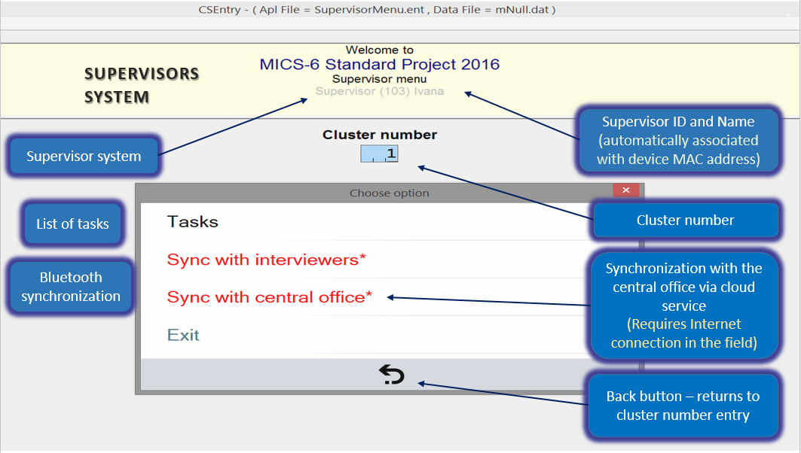

;'kl/j]If0fsf] sfo{x? z'? ug'{eGbf klxn] Sni6/df sfd ul//x]sf 6f]nLsf] ljj/0fx? 6\oAn]6sf] nflu cfjZos x'G5 . u0fgf If]q / Sni6/ gDj/ Wofgk"j{s ;xL OG6«L u/]sf] x'g' cfjZos 5 . ;'k/efOh/ d]g' ;+rfngsf] z'?df g} work assign ug{ Sni6/sf] gDj/ OG6«L ug'{ kb{5 . o;sf] nflu ;'kl/j]Ifsn] l:s|gdf :jt b]lvPsf] ls Kof8sf] k|of]u ug'{ kb{5 / tLg cÍsf] Sni6/ gDj/ OG6«L ug'{ kg]{5 .

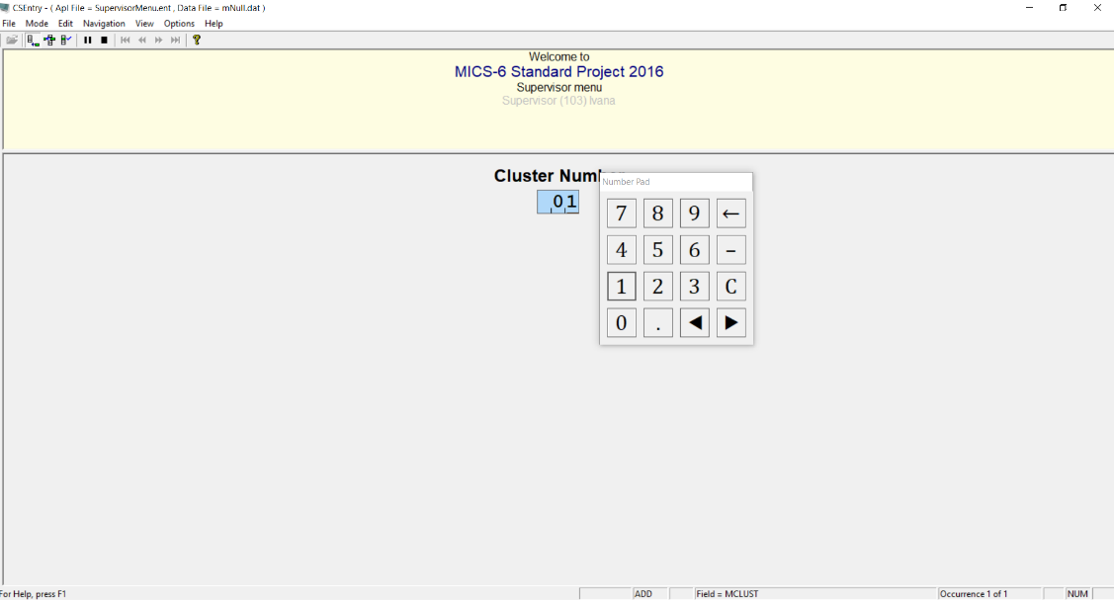

olb ;'kl/j]Ifsn] gldNg] Sni6/ gDj/ OG6«L u/]df lgDg cg';f/sf] ;Gb]z lbG5M -pbfx/0fsf] nflu 743 OG6«L ul/Pdf h'g Sni6/ kmfOndf g} gePsf]_

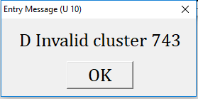

o:tf] ;Gb]z cfPdf …OKÚ 5fg]/ ;'k/efOh/ d]g'df kmls{ k'gM ldn]sf] Sni6/ gDj/ OG6«L ug'{kb{5 . o;/L Sni6/sf] ;xL gDa/ OG6«L ugf{ ;fy pQm Sni6/ vf]Ng rfxg'x'G5 egL ;f]Wg]5 . olb 6\ofAn]6df kmfOn vf]ln/fv]sf] geO{ gofF Sni6/sf] kmfOn vf]Ng vf]h]sf] ePdf o:tf] ;Gb]z b]lvG5 / vf]ln /fv]s} Sni6/df g} sfd ug{] ePdf o:tf] ;Gb]z cfpFb}g . ;Gb]zM



o; ;Gb]zdf …YesÚ df lSns u/L Sni6/sf] kmfOn vf]n] klg lgDg cg';f/sf] l:s|g b]vf kb{5 .

o;df …TasksÚ ljsNkn] ;'kl/j]IfsnfO{ :ofDknsf] lgoGq0f, u0fsn] ;+sng u/]sf 8f6fsf] ;dLIff tyf Sni6/df sfo{ ;+rfngsf cGo sfdx? ub{5 / o;sf] lj:tf/df j0f{g tn lbOPsf] 5 .

…Sync with interviewersÚ / …Sync with central officeÚ ljsNkx?n] 6f]nLsf u0fsx?af6 ;+slnt 8f6f Pslqt ?kdf ldnfg u/L ljefusf] s]Gb|Lo ;e{/df k7fpg lbg]5 .

/ftf] / …*Ú lrGx ePsf ljsNkn] ;'kl/j]IfnfO{ k"/f ug{ afFsL s]xL lglZrt sfo{x? ug{ ;"lrt ub{5 . pbfx/0fsf] nflu /ftf] lrGx nufPsf] …Sync with central office*Ú ljsNkn] ljefusf] s]Gb|Lo ;e{/df k7fpg' kg]{ gofF 8f6f ePsf] ;"lrt u/]sf] x'G5 .



ljsNk …TasksÚ
o;df tLg pk–ljsNkx? 5gM
- Assign households
- Review data
- Cluster operations



klxn]s} d]g'df kms{g] a6g l:s|gsf] tnlt/ /x]sf] x'G5 . 

Assign households

o; pk–ljsNk d]g' 5gf}6 ugf{ ;fy 6\ofAn]6n] 5gf}6df k/]sf kl/jf/x?sf] ;"rL k|:t't ug{'sf] ;fy} s'g kl/jf/ 6f]nLsf] s'g u0fsnfO{ sfo{ ug{ lbOPsf] jf sfo{ ug{ tf]Sg afFsL 5 eGg] b]vfpg] 5g\ . z'?df kl/jf/ ;"rL ;]tf] /+usf] ePsf] x'G5 . cGtjf{tf{ ug'{ kg]{ kl/jf/ 5flgPkl5 6f]nLsf u0fsx?sf] ;"rL b]vf kb{5 / o;af6 ;'kl/j]IfsnfO{ s'g kl/jf/ s'g u0fsnfO{ sfo{ ug{ lbg] eGg] ljsNk b]vfpF5 . o;/L u0fs cg';f/ kl/jf/ 5gf}6 ugf{ ;fy tf]lsPsf] kl/jf/sf] x/km v}/f] /+udf kl/0ft eO{ u0fs cg';f/ b]lvg] eP/ a;]sf] x'G5 . u0fsnfO{ kl/jf/ tf]ls ;s]kl5 kl/jf/sf] x/km gL/ -xl/of] lgnf] ldl>t_ /+udf b]vf k/]/ a:5 . ;a} kl/jf/sf] cGtjf{tf{sf] nflu Ps}rf]l6 u0fs tf]Sg cfjZos 5}g . ;'kl/j]Ifsn] cfjZostf / kl/l:ylt cg';f/ s'g} klg u0fsnfO{ s'g}klg kl/jf/ tf]Sg ;Sg] ;'ljwf o;df pknAw u/fPsf] 5 .

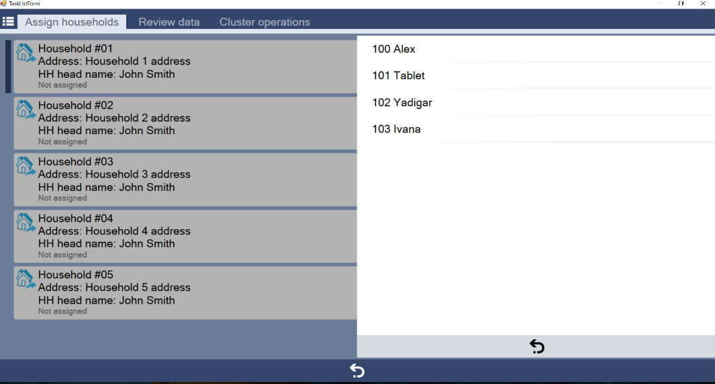

olb ;'kl/j]Ifsn] s'g} kl/jf/sf] cGtjf{tf{sf] nflu u0fs kl/jt{g ug{ rfx]sf] ePdf jf sfo{ tf]ls;s]sf u0fsnfO{ 5gf}6df k/]sf Sni6/df gofF kl/jf/ k|fKt eO{ yk ug{ rfx]df lgDg cg';f/sf] d]g'df hfg'xf];\M

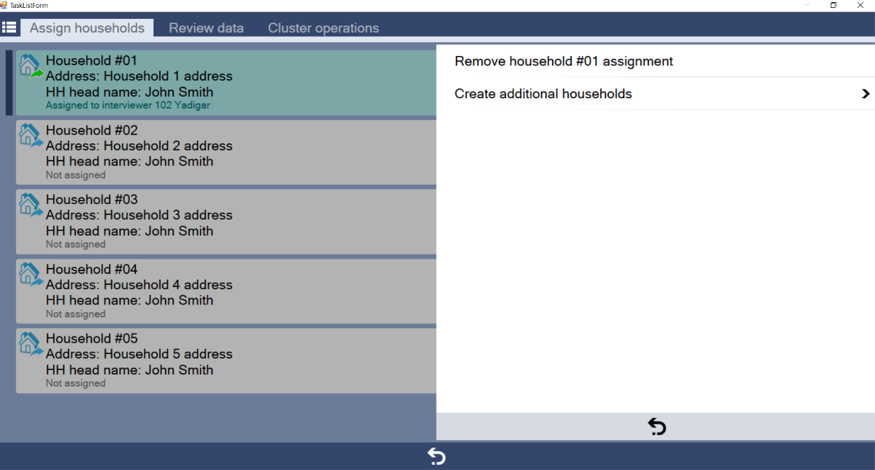

d]g'df b]lvPsf] kl/jf/ 5gf}6 ug{ xfOnfO6 ubf{ kl/jf/ ;"rL k]ml/ v}/f] /+udf kl/0ft x'g hfG5 . o; d]g'df u0fsnfO{ tf]ls;lsPsf] kl/jf/ kl/j{tg jf x6fpg jf kl/jf/ ;"rLs/0f ubf{ 5'§]sf kl/jf/sf] sfo{ yk ug{ ;'ljwf pknAw u/fPsf] 5 . olb cGtjf{tf{sf] nflu tf]ls;s]sf] kl/jf/nfO{ ;f]af6 x6fOPdf kl/jf/sf] x/km k'gM ;]tf] /+udf kl/0ft x'g hfG5 .

Review data

o; ljsNkdf cGtjf{tf{ ;lsPsf s'g} kl/jf/ jf JolQmut k|ZgfjnLsf] ;dLIff÷hfFr ;'kl/j]Ifsn] ug{ ;Sg] ;'ljwf pknAw u/fPsf] 5 . oxfF u0fsx?n] kfl/jfl/s ljj/0f ;+sng ug{ tyf JolQmut k|ZgfjnL eg{ cGtjf{tf{sf] nflu k|of]u ubf{s} k|f]u|fd kl/dflh{t df]8df v'Ng hfG5 / ;'kl/j]Ifsn] OG6«L eO{;s]sf] ;a} 8f6f x]g{ ;Sg]5 . t/ tL 8f6f ;]e gePsf sf/0f ;'kl/j]Ifsn] s'g} x]/km]/ ug{ ;Sg]5}g . pQm 8f6fdf s]xL kl/jt{g ug{ rfx]sf s'/fx? ;a} sfuh÷gf]6a'sdf l6k]/ u0fsn] 8f6f ;+sngsf] nflu k|of]u ul/Ps} k|ZgfjnL ;lxtsf] 6\ofAn]6af6 ;+zf]wg jf kl/jt{g ug'{ kg]{ x'G5 . o;}n] ;'kl/j]Ifn] ;DjlGwt u0fs;+u} a;]/ cfjZos 5nkmn u/L ;+zf]wg jf 8f6f ldnfpg lbg' kb{5 . o;/L ;+zf]wg ubf{ ;DjlGwt kl/jf/ jf JolQmut k|ZgfjnLdf g} ePsf] s'/f lglZrt ug'{ cfjZos 5 . o;/L u0fsn] ;+zf]wg jf 8f6f kl/dfh{g ul/;s]sf] klg 8f6f ldnfgsf] nflu kl/dflh{t 8f6f k'gM ;'kl/j]IfsnfO{ k7fpg' synctronize ug{' kg]{5 .

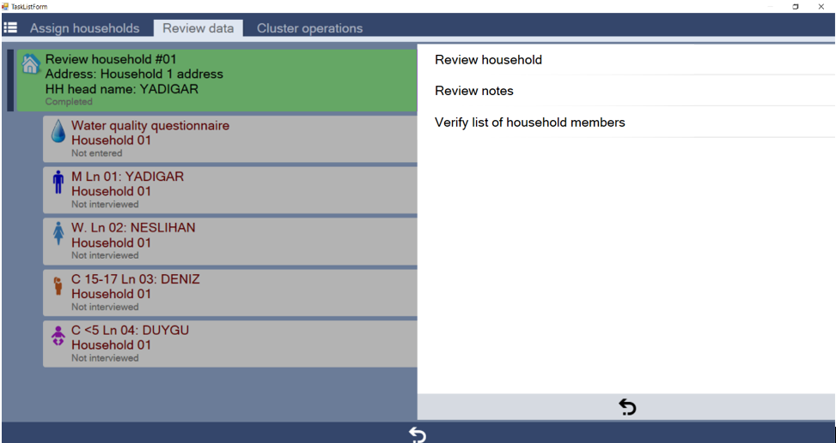

o; …Review dataÚ ljsNkdf s'g} kl/jf/ jf JolQmut k|ZgfjnLsf] ;DaGwdf ePsf l6Kk0fL -gf]6_sf] ;dLIff ug{ tyf kl/jf/sf] k'gM cGtjf{tf{ / kl/jf/ ;b:o ;"rLsf] hfFr h:tf sfo{x? ;'kl/j]Ifsn] ug{ ;Sg]5 . o;df /x]sf] pk–ljsNk …Verify list of household membersÚ af6 u0fsn] kfl/jfl/s k|ZgfjnLsf] cGtjf{tf{sf] nflu u0fsn] k|of]u u/]s} k|f]u|fd v'Ng]5 .

u0fsn] kl/jf/ ;b:o ;"rLs/0f tof/ u/]kl5 To;sf] ;f/fFz tn b]vfP cg';f/sf] 9fFrfdf ;'kl/j]Ifssf] 6\ofAn]6df b]vfpF5 . ;'kl/j]Ifsn] o;df gldNg] s]xL b]lvPdf u0fsnfO{ ;DalGwt kl/jf/df k'gM uO{ cfjZos ;+zf]wg ug{ lgb{]zg lbg' kg]{5 . Sni6/df sDtLdf Ps kl/jf/ 5gf}6 u/L k"0f hfFr gul/P;Dd 8f6f ;+sng cyf{t cGtjf{tf{ ;a} k"/f ePsf] dflgg] 5}g eGg] dxTjk"0f{ tYo :d/0f ug'{ h?/L 5 . k|lt Sni6/ Ps kl/jf/ hfFrsf] nflu clgjfo{ eP klg ;'kl/j]Ifsn] PseGbf a9L kl/jf/sf] 8f6f jf cGtjf{tf{ hfFr ug{ ;'emfPsf 5g\ . o;afx]s ;'kl/j]Ifsn] kl/jf/ jf AolQmut k|ZgfjnLx?sf] hfFrsf] ;fy} cGo ;+slnt ljj/0fx?sf] klg hfFr ug{ pT;flxt ePsf] x'g'kb{5 .

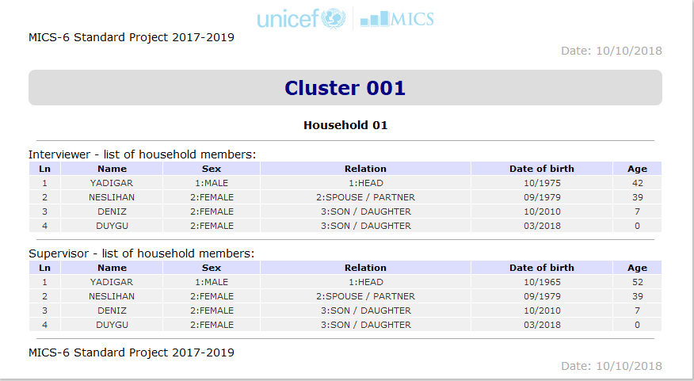

Cluster operations

o; ljsNkn] Ps Sni6/df tYofÍ ;+sngsf] sfo{ k"/f eO{;s]kl5 To;sf] hfFr tyf k|Zff]wg ug]{ ;'ljwf pknJw u/fpFb5 . o;af6 u0fsx?n] el/Psf k|ZgfjnLx?sf] ;"rL tof/ ug]{, ;+slnt tYofÍsf] 9fFrfut hfFr, tYofÍsf] tfls{s z'4tf tyf ljefudf k7fpg] kmfOn tof/Lsf sfdx? ug{ ;lsg]5 .



l:s|gdf b]lvPsf] …Close/List ClusterÚ ljsNkdf lSns u/]df kfl/jfl/s tyf JolQmut k|ZgfjnLx?sf] l:ylt b]lvg] k|ltj]bg tof/ ul/lbG5 . pQm k|ltj]bgnfO{ rf/ v08df ljeQm u/L ;dLIff ug{ ;lsG5 .
- Cluster ID: oxfF :oflDKnË kmfOnaf6 yk ljj/0fx? ;lxtsf] Sni6/ gDa/ x'G5 .
- Errors: olb Sni6/df s'g} q'l6 ePdf o; v08df ;"lrs[t ePsf] x'G5 .
- Summary: Sni6/df el/Psf s"n k|ZgfjnLx?sf] kl/0ffd sf]8 ;lxtsf] ;f/fFz .
- Details: k|To]s kl/jf/sf] k|ZgfjnLx? tyf ltgLx?sf] x/]s sf]8 ;lxtsf] lj:t[t ljj/0f .

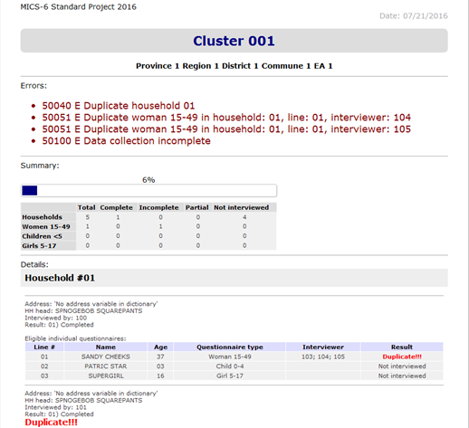

olb ;a} k|ZgfjnLx? hfFrsf] ;fy} sDtLdf Ps kl/jf/sf] ;b:o ;"rL hfFr ul/Psf] eP PlKns]zg cfkm} aGb eO{ kmfOn ljefudf k7fpg tof/ ub{5 .

t/ el/Psf k|ZgfjnLx?df 9fFrfut c;+ultx? cyjf tYofÍ ;+sng ck"0f{ ePdf lgDg cg';f/sf] ;Gb]z b]lvG5 M
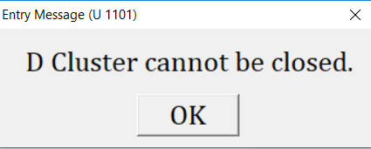

o; ;Gb]zn] ;'kl/j]IfsnfO{ Sni6/df cem} tYofÍ ;+sngsf] sfo{ k"/f ePsf] 5}g eg]/ hfgsf/L u/fpF5 .

d'Vo d]g'df kms{g]

o;sf] nflu l:s|gsf] tNnf] efudf /x]sf] AofsP/f]df lSns ug'{xf];\ .

Sync with interviewers

o; ljsNkdf uPkl5 ;'kl/j]Ifsn] cfk\mgf] 6f]nLdf /x]sf u0fsx?sf] ;"rL k|fKt x'g]5 . clg To;af6 ;'kl/j]Ifsn] cGtjf{tf{ ug'{kg]{ kl/jf/ u0fsnfO{ tf]Sg cyjf 8f6f k|fKt ug{ rfx]sf u0fs rog ug{ ;lsg]5 .
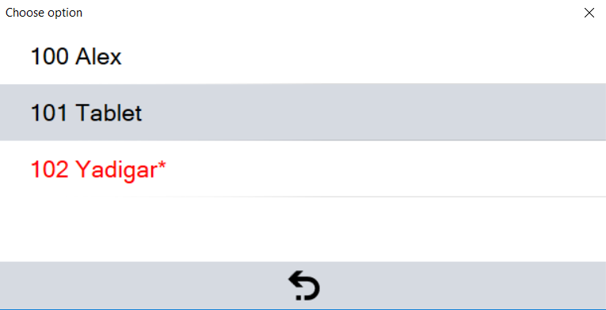

o;/L u0fs rog ul/;s]kl5 An'6'ysf] pkof]uaf6 ;'kl/j]Ifs tyf u0fssf 6\ofAn]6x? Pscsf{df ;lhn} 8f6f :yfgfGt/0f ug{ ;lsG5 . o;sf] nflu ;'kl/j]Ifs tyf u0fs b'a}n] An'6'y cg u/]sf x'g' kb{5 / u0fssf] 6\ofAn]6df …Sync with the supervisorÚ 5gf}6 u/L lSns ug'{kb{5 . of] k|s[ofsf] nflu b'a}sf] 6\ofAn]6x? glhs} /xL An'6'ysf] ;Dks{ x'g;Sg] x'g' h?/L 5 . of] 8f6f :yfgfGt/0fsf] k|s[of k"/f ePkl5 lgDg cg';f/sf] l:s|g b]vfkb{5 M

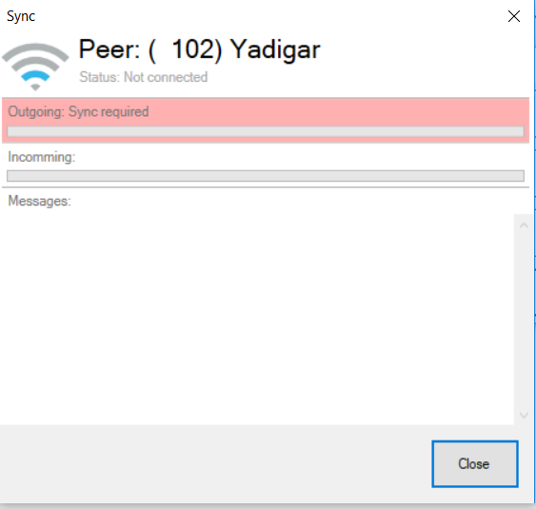

of] k|s[of ;kmntfk"j{s k"/f ePkl5 ;'kl/j]Ifs tyf u0fs b'a}nfO{ 8f6f :yfgfGt/0f ePsf] hgfp lbg]5 . o;af6 u0fsn] cfk"mnfO{ sfd ug'{kg]{ -cGtjf{tf{sf] nflu_ tf]lsPsf kl/jf/x?sf] ;"rL k|fKt x'g]5 / ;'kl/j]Ifsn] klg cfk\mgf] 6\ofAn]6df ;+slnt 8f6fsf] k|ltlnlk -skL_ k|fKt x'g]5 .

u0fsn] Sni6/df sfd z'? ug'{eGbf klxn] ;'kl/j]Ifsaf6 dfly pNn]v eP h:t} u/L 8f6f k|fKt ePkl5 cGtjf{tf{ ug{ cfk"mnfO{ tf]lsPsf] kl/jf/ lglZrt ug'{kb{5 . ;'kl/j]Ifsn] sfo{ lgwf{/0f u/]sf] d]l6Pklg u0fssf] 6\ofAn]6df ;fl/Psf] sfo{ lgwf{/0f :jtM d]l6Fb}g . ctM olb sfo{ lgwf{/0fdf kl/jt{g ul/Psf] ePdf klxn] sfo{ lgwf{/0f ePsf kl/jf/x? u0fsn] cfk\mgf] 6\ofAn]6df d]6\g' kb{5 .

Sync with central office

OG6/g]6sf] pknAwtfsf] cfwf/df x/]s lbgsf] cGTodf ;'kl/j]Ifsn] ljefudf lbge/ ;+slnt tYofÍ hfFr u/L k7fpg' kg]{x'G5 .



ljefudf ;+slnt ljj/0fx? k7fpg 6\ofAn]6df lbOPsf] ljsNksf] 5gf}6 ugf{;fy OG6/g]6 5 eg] ;Dks{ eP gePsf] af/] ;"lrt ub{5 .
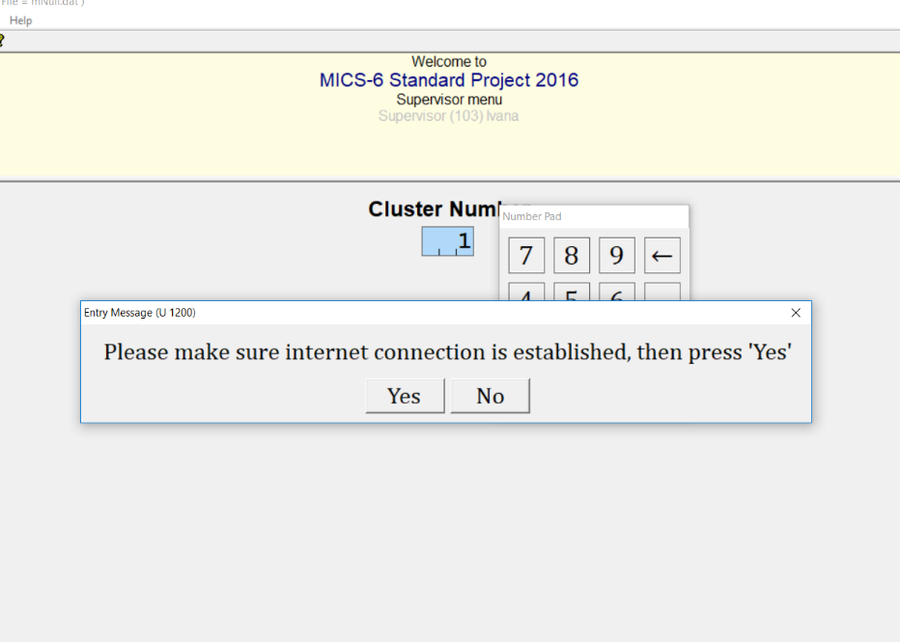

olb OG6/g]6 ;Dks{ ePsf] lglZrt ePdf ;'kl/j]IfsnfO{ k|0ffnLn] cfkm}n] 8f6f k7fpg] s|ddf 6\ofAn]6 l/:6f6{ x'g] hfgsf/L lbg]5 . o;sf] cy{ 6\ofAn]6 cfk\m} aGb eO{ :jtM k'gM ;+rfng x'g]5 / o;sf] nflu ;'kl/j]Ifsn] s]xL ug'{ kg]{5}g .

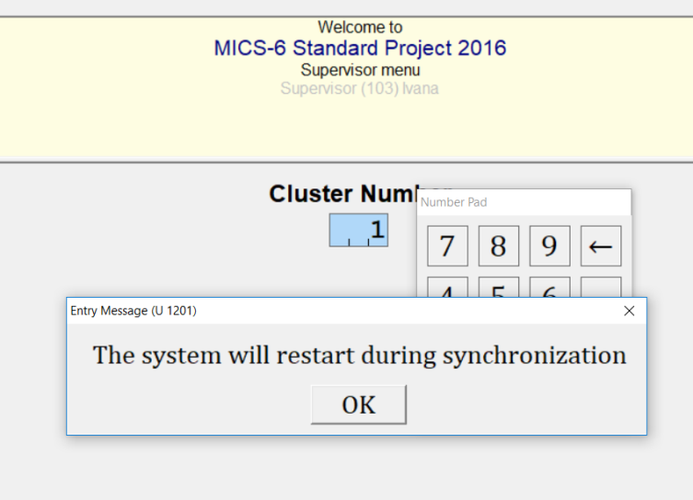

of] k|0ffnLn] OG6/g]6sf] dfWodaf6 ;'kl/j]Ifssf] 6\ofAn]6df ePsf] 8f6f :jtM ljefudf k7fPsf] x'G5 . ;'kl/j]Ifsn] d]g'df s'g} Ps Sni6/ gDa/ OG6«L ul/Psf] ePtfklg pQm 6\ofAn]6df ePsf ;a} 8f6f ljefudf ;/]sf] -skL ePsf]_ x'G5 .

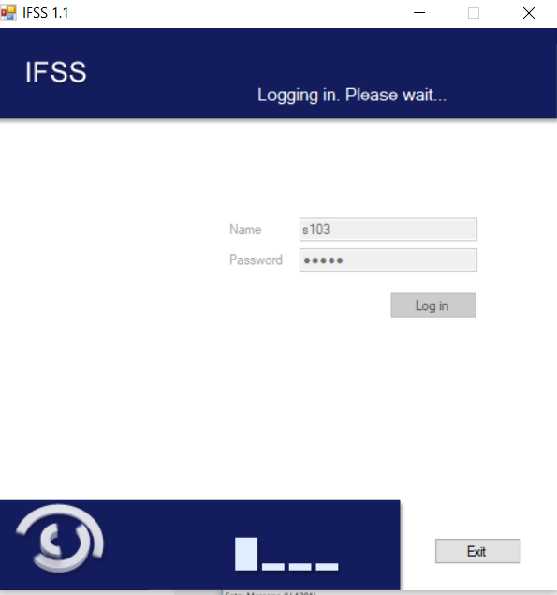

Exit

o; ljsNkdf lSns u/]kl5 ;'kl/j]Ifs d]g'af6 aflx/ hfG5 / ljG8f]df kmls{G5 .

